A Call For The Home Media Network

Gordon Bell & Jim Gemmell
Microsoft Research
“The best way to predict the future is to invent it.” – Alan Kay
”… or at least posit a vision for others to build.” – the authors

Introduction
Home media acquisition, production, storage, and use are on the cusp of a radical change as PC and network technologies integrate all media. The current home’s hodge-podge of ad-hoc analog equipment will be replaced by all-digital, networked media equipment: the Home Media Network. There is no question that this change is coming; the question is “how soon”? The goal of this paper is to spur consumer and computer manufacturers to start delivering the Home Media Network now. Early adopting users are already influencing and stimulating the market. We hope that this discussion of the issues, the advantages, and the breakthrough possibilities will evoke action.
Typical homes have a plethora of answering machines, boom boxes, cameras, computers, stereos, telephones, and TV sets. At least four independent networks carry audio, data, telephony, and TV. Some homes add intercoms, home theatres, surveillance cameras, and home automation controllers. We talk about home audio-visual (A/V) systems, but applying the word “system” is generous. For most consumers, it is difficult (or impossible) to interconnect all home components. In the living room, the proliferation of remote controls and cabling demonstrates the lack of integration (Figure 1). Stereos do have a number of connected components, including TV and VCR. “High end” homes may even centralize audio sources and amplifiers and run speaker wires to every room. However, to truly integrate all home media requires a vast collection of special equipment, a sense of humor, trained operators, and a full-time maintenance/user consultant (the responsible person in the family).
Consumer grade PCs demonstrate how media can be integrated. They can play surround sound, play/rip/write CDs, tune/record/play TV, play/write DVDs, and store/print/display photos and art. They can also act as a phone and answering machine. However, current PCs are not the answer, because they tend to be big, homely, and noisy, making them unwelcome in the living room. Also, the benefit of a PC’s flexibility and extensibility comes at the price of complexity, making their management and maintenance almost as difficult as the home A/V integration task.
We believe that a single, home network that connects a PC-based server (or servers) to specialized media IO appliances (and other devices) is likely to evolve. Network plug and play solves the installation problem. The collection of 2, 6, or 12 digital speakers play the appropriate sounds from stereo, to 5.1 and 10.2 surround sound, respectively. Network monitors display images and video. Networked microphones and cameras enable telephony, videoconferencing, and recording.

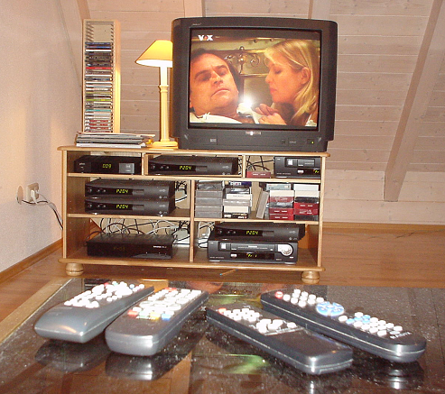
Figure 1: Remote controls and cabling in the living room demonstrate the lack of integration in simple home componentized A/V “systems”.
Instead of needing match remote controls with each A/V source, any remote control should command the unified system (e.g. pressing “pause” pauses the media in the room). However, current remote controls are too limited for the home media network we envision. A wireless mouse/keyboard is adequate, but of questionable use. Palm sized devices can control, but they are inadequate for content presentation. We believe the tablet PC will be the next generation universal remote control because it can support a very rich UI, and also display and capture media. The future holds the “promise” of control by speech and gestures.
To the technophile, a digital home media network is obvious and inevitable. There are solvable technical and political problems (e.g. copyright protection). Digital media has already invaded the home in CDs, DVDs, PVRs and portable digital music players – surely integration can’t be that far away, can it? On the other hand, one might ask: “why bother?” Why bother, indeed, when existing wiring doesn’t do the trick, much content is still analog, and the desired gear is for the high-end buyer?

Motivation
The first reason for bothering with the Home Media Network is that integration of all media into a single digital networked system decreases complexity, cabling, and cost. The second reason is to make all IO devices multi-purpose and general. Think of word processor hardware, which has been displaced by the PC: it made the most sense to make the IO devices (keyboard/mouse/display) as multi-purpose as possible. Similarly, speakers should play any sound (not just, say, radio), while a microphone should take in any sound input (rather than being just for the telephone, or the intercom, or the memo recorder). Displays should be used for anything their size and quality can support: a small display might be used as a clock and to flash reminders, while a large, high-resolution display can handle TV, DVD, home video, web pages, art, photos, and ambient environments (e.g. riding on the Orient Express).
These reasons are compelling enough, but to really appreciate the value of the Home Media Network, one needs to view it as a platform that can take advantage of software creativity to enable breakthroughs in media usage.
Perhaps you watch a TV show, and it mentions a Web site. You click “bookmark” on your remote! Later, while web surfing on a PC or TV you follow the bookmark to the web site or you simply just surf backward through your past, since the network “knows” what you were doing. You watch a baseball game, “bookmark” plays and email them to a friend, who had recorded the game. Later, she is able to watch your selected highlights. The next morning you bring up the “Times” on the ceiling display. Then you watch a video-on-demand lecture while exercising. A camera and microphone co-located with a person-sized monitor allow you to videoconference with a cyberized background.
Software systems are increasingly taking the “management” out of media-management. We posit a world without arcane, nested menus that force us to memorize channel numbers, song numbers, radio frequencies, or the special key-combination required to set the time (or record the message, or…). Software can learn the kind of music or programs we like. One can ask for songs selected by a favorite DJ, but when the DJ picks a song the system knows you don’t like, it will skip it or substitute something else. Once a song is given the thumbs down, there is no reason to ever hear it again (at least not in your home). It will also learn the kind of photos and art you like. It will dig through the 99% of your photos that you haven’t bothered to put in a photo album and present them to let you identify keepers. Device management will also be easier allowing one to simply plug any device into power and the network (Jini, HAVi, and Universal plug and play are already addressing this).
The possibilities of media software are exciting (indeed, many Ultimate TV users have become so excited that they have requested fast forward of a live broadcast!). But even without considering these exciting prospects, the status quo deserves to be put on the defensive. Why keep analog? It is not inherently cheaper. It is lower in quality. Let’s face it, analog has reached the end of its useful life, and it is time to bury it. This means a complete change in every aspect of audio and TV distribution, display surfaces, controllers, networks, computers, and how all of these work together and are controlled. To achieve this goal requires a common vision backed with effort, determination, a few standards – and getting started!

Building the Home Media Network
The first requirement for a Home Media Network is an IP network that replaces phone, and cable TV wiring. Switched 100 Mbps Ethernet is inexpensive and meets long term home media networking needs for higher quality video. Wireless, phone, and power networks operate at lower rates, limiting the number and quality of video streams, although they can be used in a limited fashion and are getting faster each year [Bell01].
Figure 2 shows a coat and “wiring closet” with wired and wireless Ethernet, wired and wireless telephony, cable and DSL modems, firewall, and a small UPS. Compare this tidy installation with your A/V and PC cabling!
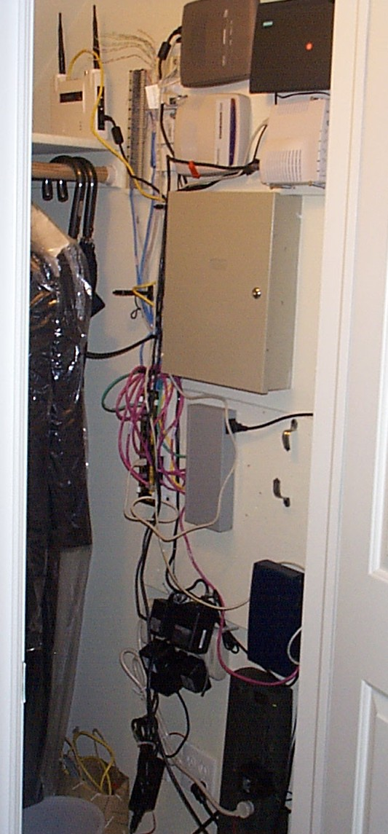
Figure 2: Home coat & wiring closet supporting: wired and wireless telephony, wired and wireless Ethernet, cable and DSL modems, battery backup, a firewall appliance, and patch panels.
The second requirement is to replace TV sets with monitors (or other digital displays such as LCD projectors). TVs are capable of some new applications, such art display (Figure 6) or TV screen savers but they are very poor at text unless fonts are very large. This means that for email, browsing, and presentations (Figure 7), very little text can be displayed at once, and most material prepared for computers is illegible. It is essential to upgrade interlace-scan TV monitors to progressive-scan, computer grade monitors that will enable text-rich and high precision applications.
Eventually, all media devices will be digital and attached to an Internet Protocol (IP) network. However, we foresee a very long interim that includes legacy analog. To cope with the transition, each legacy analog device (e.g. receiver or TV set) will be driven by a “digital transformer” that connects it to the digital network. For example, Voyetra Turtle Beach’s Audiotron feeds a stereo with audio content from the network. The next device in the genre is a “Videotron” for TV content. Figure 3 shows a home with media servers, digital transformers, and digital media networked appliances (monitor, microphone, telephone, and camera). Plug-in cards for TV capture permit early adopters to “go digital” now.
Figure 3: The Home Media Network with digital transformers to support legacy analog devices.
We posit the Mbox (for “media-box”) with powered, IP speakers, and monitor that will integrate and replace all A/V components (amplifier, tuner, CD, DVD, set-top box, PVR, and all the remotes) in a home entertainment center (see Figure 4 and Figure 5). It would typically reside in the living room or listening room, to drive each monitor and audio system. It can operate as either a server for the network or a self-contained platform. The multimedia PC is a prototype of the Mbox, however, the Mbox will be designed for consumer buying habits and sensibilities: it must be quiet, attractive, and remote control driven.
Any networked device controls the Mbox. This permits browsing the Web from a PC for TV programming, finding an interesting shows or content, and relaying commands to the Mbox to record content. Fast home networks allow optional and fungible Mbox’s storage.
The Mbox provides a considerable challenge. In general, consumer electronics manufacturers except Sony are unfamiliar with digital networks and computers. Consumer electronic standards take decades to evolve. Most likely the change will have to come from the PC industry with short, 18 month product gestation times is equally unfamiliar with television standards. Already, since the first draft of this paper was published as a technical report, Mbox type devices (see Figure 6) have been announced by Microsoft (FreeStyle), and Moxi (Media Center).

Figure 4: Existing home entertainment center
Figure 5: The “Mbox” is a digital home entertainment center with radio & TV tuners, CD, DVD, and PVR simplifies and adds functionality. Legacy media such as audio cassettes and records would be recorded ONCE digitally. All component cables and separate remotes are eliminated. Later generation systems replace amplifier and speakers with powered IP speakers!
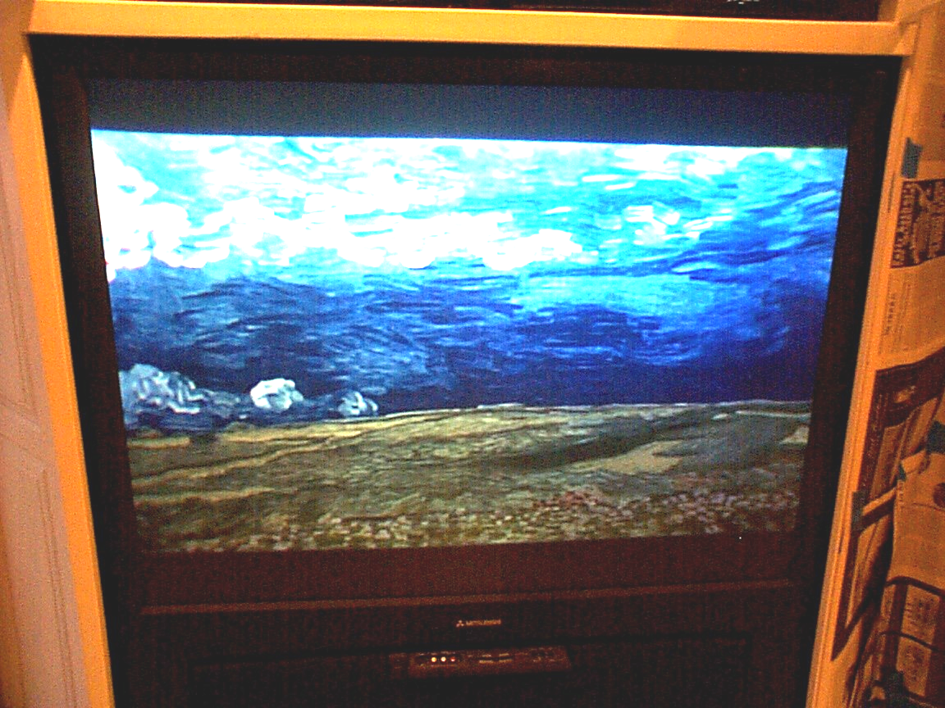
Figure 6: Digital art on a 42” projection TV (TV set as a “screen saver”).
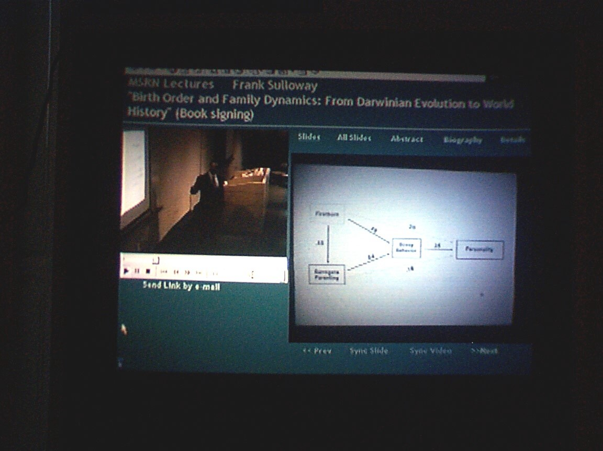
Figure 7: Telepresentation consisting of video and slides on standard home projection TV.
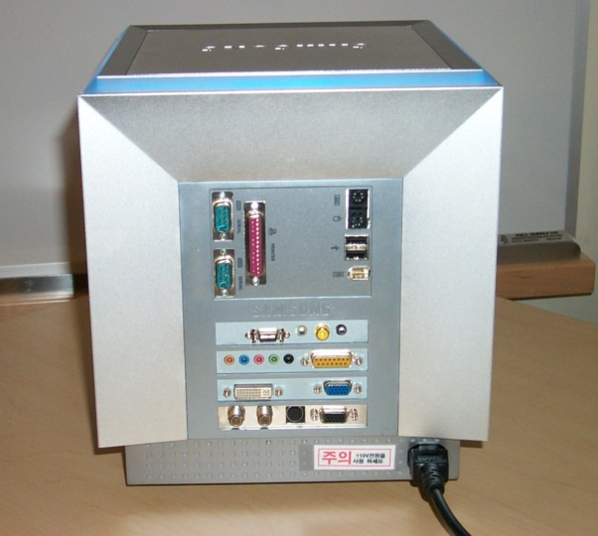

Figure 6. Rear view of prototype Mbox to interface with CATV, Ethernet, and various A/V sources.

Content distribution, storage and management
Speculation abounds regarding the future of electronic media delivery that is not carried by a physical medium (like CD or DVD). Users of Personal Video Recorders (PVRs) such as TiVo and UltimateTV have shown that they almost always time-shift TV viewing, playing video from their personal cache at their convenience, rather than watching it at the scheduled time -- “prime time no longer exists”. The same benefit applies to radio (especially when you listen from another time zone).
If content will be played from a cache, then it need not arrive in real time. It can be “stuffed” (prefetched) into the cache by any file-transfer mechanism. Real time transfer will still be needed for synchronous communication (videophone/telephone). News and sports seem to require real time transmission, but often do not. News is rarely delivered instantly. It comes on the “6 o’clock news” or in the “news cycle” of an all-news station. Viewers may prefer a cached version of the last news cast over waiting for the next one, especially if they can eliminate the commercials that absorb 10-20% of their time. Certainly sports highlights can be cached, and sports occurring in different time zones may be inconvenient to watch live. In addition to time-shifting, playback from a cache makes interactive content faster, for example, browsing the “Times” web pages from a cache dramatically improves the user experience.
Almost any distribution network is suitable for cache stuffing. Existing web dialup connections could use FTP, HTTP, IP multicast, or peer-to-peer sharing (a la Napster). Existing television channels and radio stations could be re-purposed for digital cache stuffing. Analog channels could switch to digital streams at night to stuff caches, and some digital transmissions altered for cache stuffing (sent slightly slower than real time in order to add more error correction).
On the Internet, streaming Video On Demand (VOD) is gaining popularity, and is a way of achieving time-shifting. Some observers insist that content will be stored centrally by service providers that maintain large servers (hubs). Mail services such as Hotmail and Yahoo are examples of a central approach. Photo storage sites like MSN, Ofoto and Shutterfly reinforce the trend. However, we see serious problems with a central service approach, including security, control, lack of bandwidth (for the foreseeable future), and most importantly, the cost and commitment to maintain someone’s personal files forever.
Terabyte personal stores for PCs at negligible cost are likely by 2005. These will greatly reduce the incentive to store content outside the home (and outside one’s control). Meanwhile, current last-mile bandwidth limitations prevent VOD from achieving even true TV-quality, and the cost involved in upgrading the bandwidth and scaling the video servers to achieve this quality will be far greater than the cost of adding cache space in the home for the foreseeable future. Similarly, for portable audio devices, the economics favor increasing the memory of the device rather than supporting wireless on-demand transmission. Reasonable quality streaming audio to the home is feasible over current dialup connections, so perhaps this one flavor of on-demand will survive, although it is not clear if sufficient benefits exist to win over cache-stuffing.
We believe that personal content will be stored primarily in the home, and will be stored outside the home only for the purposes of backup and sharing. Such a personal store presents its own challenges [Bell, 2001]. Like their grown corporate database cousins, managing the media server’s content, including backup, archiving, media life span, etc. will become a main consideration for the user.
While we can argue the merits of where personal content should be stored and how it should be distributed, the decision may actually be made for us by the content publishers. Publishers do not want their content to be carried in any form that might be digitally copied, so they don’t want it to pass unencrypted over any interface, and are leery about giving it to any device with a removable store. For example, UltimateTV integrates PVR functions with channel tuning such that no interfaces are introduced that would allow digital copying. Going even further, PVRs and DVD players ensure that their analog output is impossible for most VCRs to tune (and VCR manufacturers are “good citizens” by ensuring their tuners are not robust as those of TVs). Also, content distributors have a problem with time-shifting if the viewers can skip the commercials that pay for the content/distribution (and, for radio in the USA, recording changes the distribution category, requiring increased royalty payments).
Before willingly participating in the next generation of media distribution, publishers will insist on Digital Rights Management (DRM) to protect their content and ensure their revenues. As DRM matures, cache stuffing will allow for some interesting opportunities such as ad-insertion and pay-per-view that can please both viewers and distributors. Sadly, sorting out DRM will involve legal and politic issues, that may delay progress. The danger of content protection schemes is that they may also protect the status quo, and keep us from realizing some of the exciting new prospects of the Home Media Network. For example, one way to protect video content is to have a tuner device that tunes and decodes an encrypted stream and overlays it directly on the video output. This makes manipulation or analysis of the content is impossible, preventing the key value additions of computerization. A key piece of the Home Media Network will be DRM that enables computer manipulation, rather than disabling it.

Conclusions
The Home Media Network will be a single IP network within the home that connects externally to the Internet, telephone, and CATV networks. Media will flow between home servers and network IO appliances. This network will enable new content management and distribution, and make time-shifted listening/viewing the norm. Many of the components of a home entertainment center will be replaced by a new network appliance: the “Mbox”. Legacy devices, like TV sets, will connect to the Home Media Network via “digital transformers”.
The speed at which the vision of the Home Media Network materializes is up to the content suppliers and distributors together with the computer and consumer electronics industries. The consumer electronics industry must give up on analog – including cable TV, interlace scan TV, and legacy audio. We’re confident the computer industry will provide alternatives to the monolithic PC. The approach must also allow for the “disintegration” of the PC, where IO components become networked devices.
The lineup for home media networking is in place: low-cost, high-capacity disk drives heading to a terabyte, excellent compression and networking standards, and a host of prototypical PCs. The thorniest issue is Digital Rights Management to protect intellectual property theft, but progress is being made. It is clear that now is the time for industry to make the Home Media Network a reality.

Acknowledgements
We have been influenced by various colleagues including Tom Blank (for demonstrating powered, IP speakers), Jim Gray, Dave Marsh, Patrick Schmitz, product managers at Turtle Beach, and Microsoft’s UltimateTV and eHome teams.

References
[Bell01] Bell, G. and Gemmell, J., “A Call For The Home Media Network”, Microsoft Research Technical Report TR-2001-52, May 2001.
Bell, G. and J. Gemmell, "On-ramp Prospects for the Information Superhighway Dream", Communications of the ACM, Vol. 39, No. 7, July 1996, pp 55-61
Bell, G. "A Personal Digital Store", Communications of the ACM, Vol. 44, No. 1, January 2001, p86-91.

A terabyte of disks can already be purchased for under $2000.

