Meerkat and Tuba: design alternatives for randomness, surprise and serendipity in reminiscing
John Helmes, Kenton O’Hara, Nicolas Vilar, Alex Taylor,

1 Microsoft Research Cambridge
7 J J Thomson Avenue
Cambridge
CB3
john.helmes@microsoft.com

Abstract. People are accumulating large amounts of personal digital content that play a role in reminiscing practices. But as these collections become larger, and older content is less frequently accessed, much of this content is simply forgotten. In response to this we explore the notions of randomness and serendipity in the presentation of content from people’s digital collections. To do this we designed and deployed two devices - Meerkat and Tuba - that enable the serendipitous presentation of digital content from people’s personal media collections. Each device emphasises different characteristics of serendipity that with a view to understanding whether people interpret and value these in different ways while reminiscing. In order explore the use of the devices in context, we deployed in real homes. We report on findings from the study and discuss their implications for design.
Keywords: Reminiscence, Photo sharing, Serendipity, Interaction, Social Media, Robotics, Screens, Iterative design.
1 Introduction
With digital technologies becoming more embedded into everyday lives, people are accumulating vast amounts of personal digital content - music, photos, videos, Facebook posts. Over time, as these collections continue to grow, items that are no longer explicitly accessed can become forgotten – undergoing the digital equivalent of “gathering dust”. With this, potential opportunities to evoke the personal meanings and memories inscribed in these digital objects during consumption, is also lost [25 t/m 28]. An interesting design challenge, then, is how we might facilitate the revisiting of such digital content that might otherwise remain hidden and forgotten.
One significant approach to this issue has been to employ notions of randomness and serendipity. Rather than goal driven access of these materials, responsibility for choice is deferred to a system that randomly accesses and presents content for consumption. This kind of approach has been employed, for example, in music listening devices with the well-established shuffle function as well as photo display technologies [2] [4] [16] [17]. Studies, by Bull [4] and Leong [16] have highlighted how such random led consumption can be an important source of value and meaning for people. But to use this as a point of departure for design, we must understand further some of the properties of random led consumption of media that lead to values such as joyful serendipity.
Leong’s work is particularly significant here, articulating a number of key factors underpinning the values of randomness and serendipity in media consumption. First of all there is the issue of choice abdication. Deferring choice to a system through randomness not only obviates the practical need for interaction but can also be important when people become “paralysed” by an overwhelming number of choice possibilities [3]. Second, randomness introduces elements of chance, luck and surprise and the related issue of anticipation. The value of these elements can be seen in many everyday activities such as games of chance and rituals such as opening presents [1]. Third, there is the notion of defamiliarisation [22] in which the placement of things in unfamiliar and unusual contexts can cause people to re-examine their assumptions around existing concepts and ideas. Juxtaposing content in new ways and against new contexts can lead us to reinterpret content with new and meaningful inscriptions. Key here are the interpretative acts that accompany this randomness. In part, this is about the interpretation of new relationships between content and mediated memories. But it also concerns interpretation of the significance of why these random relationships have been generated with people sometimes looking to higher level and unexplained forces to make sense of the randomness they are presented with. The importance of this interpretation as a value brings to mind the arguments of Gaver and colleagues around ambiguity and how one might design explicitly to encourage interpretive acts [10] [21]. In these acts of interpretation, there are also concerns with a sense of agency. That is, to what extent can these acts of randomness be attributed to something meaningful and purposeful on the part of the system creating the events.
Within this framework then, it can be seen that there are a number of dimensions on which we can target the design of systems. This means going beyond simply the design of a randomness function, to thinking about additional factors such as, facilitating anticipation, and surprise, attributions of agency and above all the interpretive acts that accompany this. In particular how can we do this in a way that fits neatly in with people’s everyday practices? In this paper, we explore some of these issues. We do this through a presentation of some novel technology prototypes, Meerkat and Tuba, whose designs relate to different elements from this framework of randomness and serendipity.
2 Related work
With the increasing proliferation of digital capture and presentation technologies, there is a growing body of research that is exploring the relationship between personal digital content and practices of reminiscing. This is turn has drawn on work from anthropology that explores the material aspects of our reminiscing behaviours. For example, work by Chalfen et al [5] looked at the everyday social practices around photo displays in the home through which family norms, traditions and values are expressed and maintained. Drawing on this work within the context of HCI, Crabtree et al. [6] and Frohlich et al. [9] further articulated the values of collocated photo sharing practices and the accompanying storytelling and reminiscing practices. Further reasons for collecting and keeping content, addressed in the work of Kirk et al [14] refer to the importance of maintaining link to one’s history as a form of legacy and also to keep certain special people in honorium. Kirk et al [15] describe several practices people undertake with their photo collections prior to sharing it with others. Of interest to us specifically is how these practices shape and influence the possibilities for presenting and interacting with large digital collections. Of particular significance, as highlighted by Kirk et al [15], and in spite of research and design effort to facilitate viewing, browsing [11] and searching [12], people infrequently look back through, let alone search their collections. When they do, they are more likely to deal with recent content.
Our approach to interacting with these large collections focuses on facilitating experiences that arguably try to fit better into people’s existing rituals and daily practices; similar to the approach of dedicated digital photo frames that are increasingly making their way into family households. An area of great interest and explored widely within the HCI community; unpacking emergent practices and family values through interactions with novel photographic technologies in domestic life [19] and [24]. A similar approach is undertaken in the work of Durrant et al [8] in which a novel content displaying prototype reveals several design implications for these types of devices, providing a new interaction mechanism and exploring what it means to present/interact with content from different identities on a single device.
Within this work it was our attempt to further elaborate on the material properties of photo display devices [23], by exploring qualities like choice abdication, uncertainty, surprise and agency [16] for the devices’ interaction mechanisms.
3 Design approach
We have taken a practical stance towards the exploration of alternative devices for reminiscing practices. As this activity often manifests itself as a conscious interaction with our computers, mobiles and digital photo frames, it was our intention to engage people in novel ways with their digital content. The designed artifacts each addressed a different approach to representing personal digital content stored on our computers, without necessarily trying to superimpose any kind of specific usage [10]. The following sections describe our design goals and decisions in more detail.

Bespoke
It was our intention to design dedicated devices for reminiscing about digital personal content within a domestic setting. We explicitly wanted to steer away from reminiscing as a side-product of a multi-purpose device or system. In addition, the design had to be compact in order to support potential repositioning in different places within the home.

Engaging
We intentionally tried to engage people in new ways with their digital content, trying to steer away from using screens mostly as a static presentation entity. Hence, we wanted people to more actively engage with them by trying to emphasize their materiality and tangible interaction qualities.

Serendipitous
We explored novel presentation and interaction mechanisms to allow moments of anticipation and surprise, e.g. by integrating elements of choice abdication, defamiliarisation and agency. By highlighting on these characteristics, we hoped to further enhance people’s engagement and interpretive practices surrounding their reminiscing experiences.

Effortless
By initiating an automated way of collecting personal content from people’s digital repositories we wanted to make the effort of using and populating the devices with content as effortless as possible.
4 Designing the devices
Apart from taking these general design goals into account we further specified two different directions for the design of the devices in order to explore alternative interaction mechanisms in parallel. With our first design, called Meerkat, we explored the notion of pushing content towards the user, to grasp the user’s attention. In contrast, our second design, called Tuba needs a deliberate action from the user in order to pull content from the device. Throughout the design of Meerkat and Tuba we applied an iterative design process in which several different fidelities of explorations led to the final instantiation of Meerkat and Tuba (see fig 1). The next sections describe the two designs in more detail.

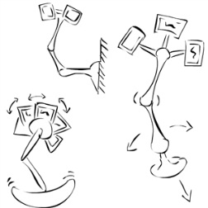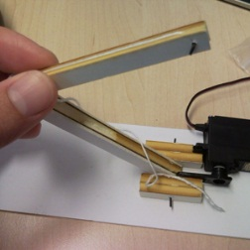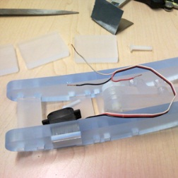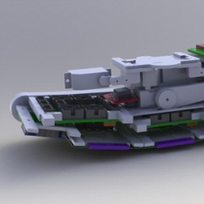
b
c
d
a
Fig. 1. Pictures of the iterative design process of Meerkat, some early sketches (a), cardboard exploration (b), acrylic exploration (c) and part of an exploded view in Solid Works (d).

4.1 Designing Meerkat
As illustrated in figure 2, Meerkat is a robotic entity consisting of 3 displays on a moving mechanical arm for displaying combinations of photographs. Over time, as the name suggests, Meerkat randomly pops up with an eccentric movement of its arms and displays to reveal new combinations of pictures.

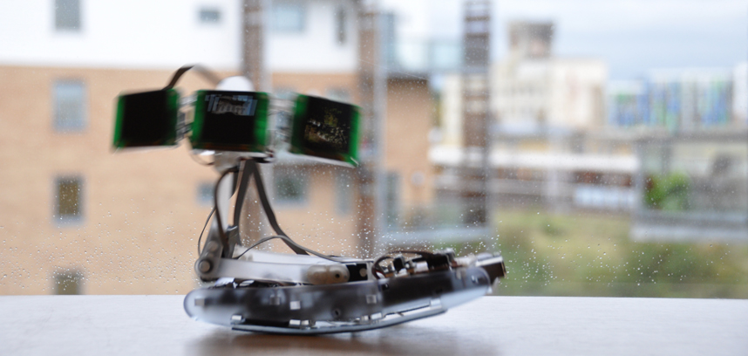
a
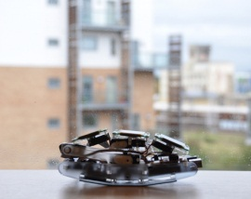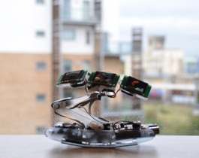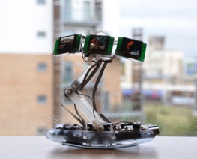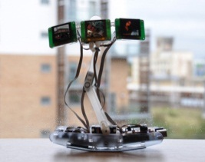
b
c
d
e
Fig. 2. Meerkat moving sideways (a), folded (b), moving up (c&d) and completely up, displaying content (e).
Broadly, Meerkat can be dissected in three parts. The base of Meerkat houses most of the electronic components, a servo, and is designed in a slightly curved fashion. This curvature allows its servo-enacted movements to amplify its empathic characteristic. Its middle part consists of two arms that, equipped with another two servos, allow it to move up and down and in various other curious ways. The top of Meerkat’s incorporates three small screens for presenting digital content. Each screen has a servo attached to it in order to further increase its movement vocabulary. In addition, another servo allows the 3 screens to be tilted into the direction of the user. Whenever in folded position, Meerkat’s screens do not display content. When it decides to pop up, it randomly selects and presents three images stored on the SD-card. As well as popping up at random intervals, Meerkat also responds to people’s presence. An embedded IR sensor detects close presence that triggers it to start displaying content. Meerkat is designed in such a fashion that ignoring it will prompt it to pop up more frequently, asking for attention. In contrast, actively triggering it has an opposite effect, reducing the frequency with which it pops up. As such the design dynamically plays with engagement levels. Meerkat has a total of 7 distinct, pre-programmed behaviours. It can also come up with subtle movements itself by moving a combination of its joints for random amounts of times and direction. Its final decision on how to move is semi-random as it also depends on whether it has been interacted with recently and whether its IR sensor is actively receiving data.
There are a number of features of the Meerkat design that relate to our concerns with regards to serendipity, reminiscing and surprise. The device is semi autonomous in its movements and presentation of content, not requiring direct interaction from a user in order for new content to be revealed. As well as providing a gentle way of alerting attention to the device, this autonomy gives the device a perceived sense of agency. The eccentric movement vocabulary of the device is also designed to enhance the sense of agency perceived in the device and aims to affect interpretation of the device’s randomness and serendipity. The movements were not designed with any immediate and obvious semantic qualities, though we wanted to see whether people might begin to recognise certain patterns of behaviour within Meerkat. As well as contributing to a sense of agency, then, we wanted to see whether the users’ emerging understandings of the movement vocabulary might influence the interpretations of the photographs – that is questioning why particular photo combinations were revealed in the context of particular movements. Finally, the display arrangement plays a role in a number of ways: first, the face-like qualities created offer additional opportunities for anthropomorphic interpretations of the device and perceptions of agency; second, it increases the movement vocabulary; third, the juxtaposition of 3 random photos provides a mechanism for defamiliarisation of the content and new possibilities for interpretation of serendipitous and coincidental presentation of content.

4.2 Designing Tuba
Our second device, called Tuba, is shown in Figure 3. Again, it is used for the random presentation of digital media from a person’s media archive. In contrast to Meerkat, content is revealed and changed through a deliberate act on the part of the user. Our aim in the Tuba design was to embody anticipation and surprise in the interaction control mechanisms. As with artifacts such as gifts or trinket boxes, the excitement is in not knowing what is hidden inside. Anticipation is created through the process of revealing the hidden. With Tuba, the user needs to explicitly “open” device to reveal the screen. Each time Tuba is opened up a piece of digital content gets revealed. By means of this simple, conscious and physical interaction, Tuba creates anticipation, as it is a surprise what gets presented each time the display is revealed. Secondly, to further elaborate on the notion of anticipation and curiosity we diverted from merely presenting one content type, as was the case with Meerkat. Increasing the variety of different media types, we envisioned the level of anticipation and curiosity to rise as well. As such Tuba was populated not just with digital pictures, but also with music, Facebook wall postings and general knowledge facts. Again, as well as emphasizing qualities like randomness and surprise some of the media types introduced defamiliarisation - for example, presenting historical Facebook posts outside their originally intended context.

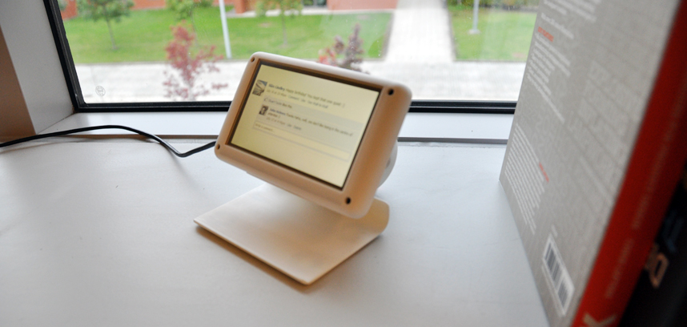
a
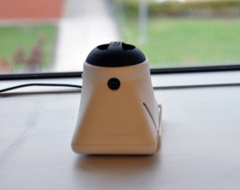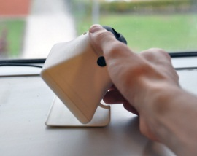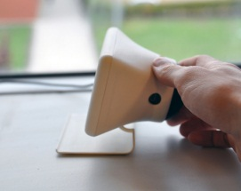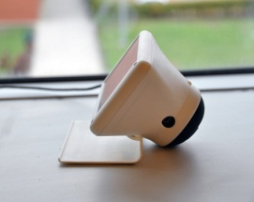
b
c
d
e

Fig. 3. Tuba opened up and displaying a Facebook post (a), in closed position (also for playing music/audio files) (b), Tuba being tilted backwards revealing the screen (c, d & e).

In addition, the device also contains a generic speaker, which, whenever Tuba is closed, points upwards. The part holding its screen and speaker can be tilted backwards in order to reveal the screen. Each time Tuba is opened up (the screen revealed) it presents a single media item. In case this media item is a song or a more generic audio file the user would be prompted by an on-screen message to close Tuba again in order to listen to the music. We wanted users to close Tuba to listen to the music as in closed position the speaker points upwards into the direction of the person as opposed to the opposite direction. In addition to this practical reason the distinct positions further emphasized Tuba’s different media presentation capabilities (displaying content and playing audio file).

4.3 Content scraper
In order to populate the devices with content we created a content scraper that automatically scrapes people’s hard drives (or parts of it, based on a pre-defined folder path). Programmed in C# and making use of the Microsoft Windows search API, our scraper searches for a pre-defined number of .jpeg, .jpg, .bmp, .png and .mp3 files. In an ideal situation one could imagine running the scraper on a dedicated computer system automatically updating the devices with content. Nevertheless, we decided not to fully implement this aspect of the system for two reasons. First, with the design and deployment of Meerkat and Tuba it was our goal to create an engaging and serendipitous experience without investing too much time in the hidden technological back-end. Second, people would still have to consciously select folders on their computers that they would be happy with displaying on the devices. More detail about the process of populating the devices can be found in the next section.
5 User evaluation
In order to investigate people’s behavioural practices around Meerkat and Tuba we executed a series of qualitative tests in real world settings and contexts. The devices were deployed within four different families for a period of two weeks each, during which each family received one Meerkat and one Tuba. Throughout an introductory session the families were interviewed about their current reminiscing practices and received an introduction about the devices. We solely provided the necessary information to interact with the devices without steering towards any kind of intended use. Especially given that we were most interested in the way people tried making sense of, perceived and used the devices from their own point of view. During the session participants were asked to locate content they would be happy to upload onto the devices. In order to practically realise this process, folders (contacting collections of years of photos) were copied from people’s computers onto our external hard drive. Using our laptop we ran the content scraper to collect the media from these folders and store it on the SD-cards of the devices. On average we had the scraper collect a minimum of 600 image and 30 music files. We intentionally chose to deploy the devices within a variety of different families in order to gain insight in their impact on different social situations. It should be recognised though that there are other different types of households that would also be of interest to explore. The families we chose, then, represent our initial explorations into the types of behaviours and responses to these devices.

Family 1: A couple in their thirties, just married and living in a small apartment with one area that functions as a living room and kitchen. Both work as scientists at a University. They store their content as a shared collection on a Mac, but do not interact regularly with it. Although having a digital picture frame they haven’t found the time to set it up.
Family 2: A couple in their late 30s with two young children, a boy aged 4yrs and a girl, aged 6yrs. Living in a spacious house with a number of different rooms and large kitchen area. The father, works full and the mum does voluntary work as well as home and childcare. Their shared digital content collection lives on a PC upstairs, they do not interact on a regular basis with it and have no other ways of displaying the content.
Family 3: A couple (in their thirties) with a baby. Similar to the first couple their living room is connected to the kitchen, similar sized apartment with a slightly different layout. The husband, works as a radiologist in a hospital. Trained as an anesthetist the wife, currently stays at home as a full time mother. Storing their content as a shared collection on a MacBook, their screensaver displays the collection.
Family 4: A husband and wife in their early 40s with two young children, a boy aged 6 yrs and a girl, aged 7yrs. Both parents work. Similar to the other family they live in a spacious house with a number of different rooms. Their digital content lives on a Mac in one of the downstairs rooms but does not seem to be accessed that often.

After our initial session, we left the families to use the devices for two weeks, during which we stayed in touch in order to assist in any way if necessary. The families were asked to keep a diary and/or make use of a small Flip-type camera to document any interesting social events, thoughts and interactions that emerged from living with the devices. At the end of the two weeks a final interview took place during which we talked about particular episodes that took place during those two weeks. In some cases the diary was used to allude to particular entries and trigger conversation around social events that emerged through their interactions. The interviews were fully transcribed for the purpose of analysis.

Findings
The findings presented here represent an early pass through the data from the interviews and diary episodes. While the responses to the devices were quite varied, we have nevertheless attempted to draw out a number of key themes from the data that highlight some of the ways people oriented to the devices. In unpacking these themes, our aims are to link what we found in the interviews back to the initial design goals and different features from the serendipity framework embodied in the prototypes. The key themes we explore in this initial work relate to engagement and interpretation, fit with daily routines and influence of different content.

Engagement and Interpretation

An important question for us to consider is the extent to which the devices and their particular design characteristics facilitated engagement from the users and how this related to reminiscing and interpretations of the content. We begin our discussion with a look at Meerkat. Perhaps most significant to people’s engagement with the device were the characteristic movements of the device. The movements were seen as quirky and erratic in a humourous way. Accompanied by the mechanical noises of the servos, this gave the device a certain personality leading to anthropomorphic interpretations. Several participants made reference to it being like having a kind of “pet” around the house that was fun to watch. During one of the interviews, Meerkat was on the table and after popping up, it flopped over and rested on the arm of the participant:

M “And that’s why I feel it is a bit pet like. Cause it does, it does look a bit like a face and a body and a… Sometimes [the movements] are quite endearing. Cause you know, when you sit next to it it’ll kind of flop onto you, a bit like a dog or something you know. Like that see [Meerkat falling onto M]. And you don’t want to keep it too close to the edge but it hasn’t fallen off yet but I keep thinking it might. It’s just so erratic isn’t it?”

The movements, then, were a source of engagement in themselves. Children for example, would mimic the movements as they watched it. Through this engagement with the movement, attention was to the photos being displayed. Having personal photos on there contributed to a sense of warmth to the device:

N “You probably wouldn’t have the same warmth towards it if it didn’t have the pictures”.

What was apparent from the interviews though, was that the movements were not really interpreted in any meaningful way. Participants did not observe or notice any patterns of movement behaviour over time and as such did not really ascribe any semantic significance to particular movement patterns. In this sense, while drawing attention to the device and prompting engagement, the movements did not contribute to any sense of interpretation for why particular photo combinations were being shown – they were perceived as essentially random.

N “I don’t really connect its movements to what it is showing.

C “I don’t know, I just find myself looking at it anyways with or without the pictures cause with the movements and stuff it just grabs your attention… It just is really fun…”

There were times too when Meerkat would simply be ignored and left to its own devices. Because it didn’t require any deliberate interaction on the part of the user, it continued functioning as an ambient display, drawing attention intermittently depending on the context of other activities going on in the household. While most participants were happy to ignore the device, there were occasions when its unpredictable behaviour was distracting leading to it being switched off. For example, one couple who had a very young baby, would at times switch the device off because the sudden noises would potentially startle the baby. Some of these practical concerns, then, impact on the device’s ability to function as an ambient display that could drift in and out of attention – in turn impacting on its role to promote serendipitous reminiscing behaviours within these contexts.
With Tuba, by contrast, the deliberate interaction required promoted a different sense of engagement with the randomly generated content. Of particular significance here was the opening mechanism. A number of participants commented on how this created a certain amount of anticipation, and a “magic spell” associated with the revelation of the media.

N “… I have never bothered with a picture frame - well partly ’cause I don’t think they are that attractive, scrolling through a few pictures on the wall. Whereas this one, cause you got that like little magic spell of opening it up it’s… I find it more engaging.”

Important to some participants was how the device slowed down interaction and thereby encouraged more reflection on the content. This slow reflective behaviour was felt to be something that might be lost with more efficient interaction mechanisms that would allow more deliberate browsing of the materials in search of photos you liked.

M “You would race through it then wouldn’t you - looking for something? Whereas this does slow you down definitely. I think it would get a bit too much, cause then you would be able to search for something.”

Indeed, it was this slowness of interaction and the uncertainty of what would be revealed that in some instances promoted a sense of longer-term engagement with the device. In one of the families, the young daughter had been waiting for a particular photo of herself diving while on holiday

“R has been waiting for a certain selection of photos to come up and hasn’t found that one yet.”

Each time the device was opened, the daughter would hope to see the photo, sustaining her desire to keep interacting with Tuba. Throughout her interactions she was building up excitement for that particular moment it time. Coincidentally, during the interview, we witnessed the moment when the particular photo in question finally came up on the display, much to the excitement of the daughter - this became an important social event.

[M plays with Tuba and open it again, the diving pictures comes up]
M … “oowww, R, R!!”
J “Is this the moment?”
[R comes back, walks up to M]
R “Heej, look daddy, look look look look!”
K “Is that you diving?”
R “Yeah, with my friend M, who lives in Malaysia.”
N “Yeah, that was in March, that was a big deal.”
K “So you have been waiting a few weeks for that photo to come up?”
M “We have looked at it quite a bit, so that is quite nice isn’t it? We’ll leave that we won’t close it for a bit.”
R “That’s my best friend.”
M “Careful cause if you turn it over it’ll be gone forever.”
K “So that is another issue, the leaving open, has there been a lot of it?”
M “Yes, yeah, don’t touch it you know, when you were looking at it or something like that so we were all kind of sitting around and I would for example. turn it over and R would say “don’t turn it over yet”, cause she wouldn’t be finished with it yet. She hadn’t quite digested the moment, the photo yet.”

What this episode also points to are important behaviours around non-engagement with Tuba – namely leaving the device open. In this instance, the device is left open and unavailable for further interaction because the photo, that had acquired increasing importance over time, was not wanted to be lost. In other instances too, people would leave the device open on occasion, when arriving at a photo they liked or because they wanted someone else in the family to see it who was not there at the time. The reminiscing was extended across time and other people.

R “What? More active? Yeah, I suppose so, but equally Tuba needs physical involvement doesn’t it to open and shut it each time to get something out of it and actually for us we found that…that was something we found we didn’t prioritize time for to do. So I’d often, with Tuba, find a picture I liked and think “och, beautiful picture or whatever, St Ives last year, lovely photo, really enjoyed seeing it, haven’t seen it for years and I would just leave it there.”

What this snippet also begins to point to is that for some participants, the inefficiencies of the interaction mechanisms with Tuba were at times frustrating. For those participants who interpreted as a simple content browsing tool, the interaction mechanism was laborious. This highlights some important tensions in the design and perhaps raises questions about primacy of slow and serendipitous interaction in design. For these participants, there engagement with the device was periodic, skipping through photos and other content to get to something they liked. Their concern was not so much with the slow and contemplative values enjoyed by other participants.

Fitting into daily routines

In understanding the experiences of serendipity in relation to media consumption with these devices, our concerns need to extend further beyond the relationship between form factor and the ways in which randomness may be interpreted. What is also of significance here is how these devices and the consumption of content related to the everyday routines and structures of family life within the home. Encounters with the device and content were very much contingent upon rhythms and flows of everyday family activity and their spatial and temporal organisation. In this respect for example, the location of the devices very strongly orchestrated the kind of interactions that unfolded. After initially setting up the devices at the beginning of the trial a number of the families repositioned the devices in different areas of the home, mostly based upon their presence in certain areas of the home but also in order to suit current activities and prevent obtrusion with others.

N “They were initially in the sitting room for a day/two days switched off. So I brought them in here and turned them on during breakfast time and meal times, like this.”
K “So it is more accessible in here?”
N “Yes more accessible, it goes for a good dozen times between my chores and washing up.”

The sitting room for this family was the place where they would sit and watch television to switch off and relax during the evening. With attention dominated by the television in this space, the devices were simply ignored in this spatial and temporal context of home life – any opportunities for serendipitous experiences were lost. Only by moving the devices to a different part of the house, namely an open plan kitchen and dining space, did the devices begin to fit with the kinds of family activities conducted in this space. This bounded interaction time and opportunities for serendipitous encounters to specific places, times and associated activities.
Within the two families having children, the presence of the devices was a feature of daily family get-togethers, such as breakfast and dinner, in which they functioned as conversation starters through both the displayed content and the more materialistic affordances of their interactions. In that sense, the devices seemed to have a different effect compared to static frames, creating anticipation through their curious enactment and interaction features.

R “I would turn it on after feeding the cat, almost becoming like another routine in the morning…”
K “So you’d switch it off overnight and then switch it back on in the morning?”
R “Yeah, so it kind of became part of the sort of routine of the day.”

Important here is that the devices come to be used sometimes with secondary purposes. In one family for example, it was a way of keeping the children entertained and occupied while the mother managed the practicalities of meal production, preparations for school and other aspects of family management. But the devices nevertheless did offer occasion for reflection for the family, if sometimes fleetingly, talking about content brought up during a breakfast or dinner. Interesting for us here is to reflect upon the way their interaction mechanisms triggered a more active opportunity to “break free” from daily routine; creating anticipation through the integrated elements of serendipity and creating short moments of delight, being taken away (even for a few seconds) from everyday habits.

J “What you just mentioned regarding using your laptop, was that a positive experience then?”
N “When I was doing the work on my laptop on the table? Yeah, cause the work is boring… ehm… cause I was desperate for distraction and it’s not that it interrupts the work at all. It doesn’t really get in the way it’s not like it was interrupting my flow of thought on my website repair.”

Content type

One of the features of Tuba was the ability to presentation different content types and as we see in the fieldwork, these different content types had an important impact on experiences with randomness and serendipity. First of all, variety of content added an additional element of uncertainty and surprise with regards to what would be encountered on any given interaction. This level of uncertainty, then, offered some value in terms of curiosity and surprise but at other times potentially frustrating when an undesired content type arose. This is a delicate balance to orient to in the design. In practice, what also appeared to impact on people’s serendipitous experiences at this level of content was the ratio of different content types. Typical in the installations was that photographs were the dominant media in terms of number, making them much more likely to appear than other media types. This ratio of media types then is important to orient to in the design of serendipitous encounters. But over and above concerns with surprise and serendipity is that people oriented to the content types in different ways, some people wanting more photos, others more Facebook content.

A “I think the music sounds better if you do it that way and the pictures look better if you do it that way. Erm, but I sort of like the idea that it was sort of one device that was playing with these different functions.”
S “Yeah.”
K “Was it good that you didn’t know what content or content type it was going to come up with or was that just annoying?”
A “No I think that actually was very good, because, yeah, if you wanted to see a certain picture or play a specific song you would do that on your iPod or something ehm, so coming up with a more random thing I thought that was quite good…those made it fun I suppose if it didn’t do that than you would sort of loose your point I guess.”

What was also significant about the different content types were the different ways people oriented to their presentation. Facebook posts for example, provided some humorous reflection by those who had posted them and by their partners. But these posts also seemed to cause concern in terms of their presentation in public settings, for example, when there were visitors to the homes. Because the content originated from a variety of different sources and has been written up for different audiences, the presentation of it in a dynamic, social context was not so simple, in particular because of the need to account for and explain the information in the excerpts, or because of the need to present only certain facets of the self within the context of particular audiences. In the following excerpt one of the participants expressed her embarrassment when having visitors over.

A “Yeah, when new people arrived and played with it a bit.”
S “Because it had so much embarrassing Facebook stuff I actually didn’t show the mums….” [laughing]
K “Why would you be embarrassed about having a heavy night?”
S “It’s just like I don’t have to explain every single instance to them each time.”

So the integration of a variety of different content types had both positive and negative effects. On the one hand it contributed to the element of surprise by abdicating choice and increasing the participants’ levels of engagement. On the other hand, the broad topic range and different content origins led to some mismatch in expectations as well.
5 Conclusion/Discussion
With the design of Meerkat and Tuba it was our goal to create devices specifically for reminiscing purposes, steering away from existing digital content presentation technologies. By introducing elements of agency, randomness, defamiliarisation, surprise and choice abdication we explored possibilities to further engage people with their personal digital content. The deployments gave us much more insight into people's acceptance and rejection of such technologies and why certain features worked well in specific contexts whilst having opposite effects in others. Though we took contextual aspects into account with the design of the devices, it was evident how aspects like people's stage in life, their family situation and daily rituals (or the lack of) had a very pronounced effect on the participants' perception and interactions with the devices. Meerkat and Tuba either resonated well with existing socio-contextual qualities or they simply did not at all. Nevertheless, as alluded to in the previous sections, the exact reasons are complex. Therefore, it is essential to strike a careful balance with regards to the integration of the described attributes as main functionalities of an appliance. As with Tuba and Meerkat's manifestations, it was sometimes felt as if the systems were “trying too hard”. People had a certain expectation whilst interacting with the devices, but that expectation seemed, to some extent, to decrease the chance for a serendipitous and delightful interaction to emerge. If the presentation of the content were a by-product of another meaningful interaction, the manifestation of the attributes for engagement would potentially have been stronger. Therefore, we believe the design for serendipitous experiences has to some extend disappoint as well in order to be effective.
The notion of these devices within daily family routines is an interesting one, especially taking the richness and diversity of the activities. Nevertheless, the devices’ flexibility to adapt, change and respond in various ways in specific situations is still limited. Especially given the fact that the differences in family setup require quite a significant difference with regards to the objects’ autonomy and interaction mechanisms. In this sense, a way for users to tweak these aspects (e.g. their level of “involvement”, from static frame to an attention seeking agent) would be very beneficial. Not just to adapt to certain social situations but also to try and keep breaking daily routines, as certain interaction patterns might become too monotonous. This represents an opportunity for further exploration in future work. On a similar note, a fully automated content scraper raised questions as well about manually influencing the content source. This was not so much a question of privacy but much more practically; as computers, hard drives are used as backups they often contain multiple copies of similar content. Though manual management of digital content is often considered to be rather laborious and thus seen as a threshold for people to actively do something with it, especially since we are creating ever increasing amounts, there is something about these manual actions that increases value to the collections. Content being brought together (e.g. in a scrapbook) increases the content’s value making it interesting to further explore the material qualities and ways the introduced engagement mechanisms could feed into this stage.
6 References
- Aczel, A. D. (2004). Chance. New York: Thunder's Mouth Press.
- Bentley, F., Metcalf, C., & Harboe, G. (2006). Personal Vs Commercial Content: The Similarities between Consumer Use of Photos and Music. In Conference of Human Factors in Computing System, Montreal, Quebec, Canada.
- Botti, S., & Iyengar, S. S. (2004). The Psychological Pleasure and Pain of Choosing: When People Prefer Choosing at the Cost of Subsequent Outcome Satisfaction. Journal of Personality and Social Psychology, 87(3), 312-326.
- Bull, M. (2006). Investigating the Culture of Mobile Listening: From Walkman to Ipod. . In K. O'Hara & B. Brown (Eds.), Consuming Music Together: Social and Collaborative Aspects of Music Consumption Technologies (pp. 131-149). Dordrecht, Netherlands: Springer.
- Chalfen, R. (1987) Snapshot Versions of Life. Bowling Green State Univesity Press, Bowling Green.
- Crabtree, A., Rodden, T., and Mariani, J. (2004) Collaborating around Collections: Informing the Continued Development of Photoware. In Proc. CSCW 2004, ACM Press, 396.
- Durrant, A., Taylor, A.S., Frohlich, D., Sellen, A., and Uzzell, D. (2009) Photo displays and intergenerational relationships in the family home. In Proc. HCI 2009, British Computer Society, 10.
- Durrant, A., Frohlich, D., Sellen, A. and Lyons, E., (2009) Home curation versus Teen Photography: Photo displays in the family home, in International Journal of Human-Computer Studies, Elsevier.
- Frohlich, D., Kuchinsky, A., Pering, C., Don, A., and Ariss, S. (2002) Requirements for photoware. In Proc. CSCW 2002, ACM Press, 166.
- Gaver, W., W., Beaver, J., & Benford, S. (2003) Ambiguity as a resource for design. In Proc. CHI '03, ACM, 233-240.
- Huynh, D. F., Drucker, S. M., Baudisch, P. and Wong, C. (2005) Time Quilt: Scaling up Zoomable Photo Browsers for Large, Unstructured Photo Collections. In Proc. CHI
2005, ACM Press, 1937-1940.
- Kang, H., Shneiderman, B. (2000) Visualization Methods for Personal Photo Libraries: Browsing and Searching in the Photofinder. In Proceedings of IEEE International Conference on Multimedia and Expo.
- Kim, J. and Zimmerman, J. (2006) Cherish: Smart digital photo frames for sharing social narratives at home. Work in progress CHI 2006, 953.
- Kirk, D and Sellen, A. On Human Remains: Excavating the Home Archive. Microsoft Research, Cambridge, UK.
- Kirk, D., Sellen, A., Rother, C., and Wood, K. (2006) Understanding photowork. In Proc. CHI 2006, ACM Press, 761.
- Leong, T. (2009) Understanding Serendipitous Experiences when Interacting with Personal Digital Content. PhD Thesis, University of Melbourne.
- Levy, S. (2006). The Perfect Thing: How the Ipod Shuffles Commerce, Culture and Coolness. New York: Simon & Schuster.
- Lindley, S. and Monk, A. (2008) Social enjoyment with electronic photograph displays: Awareness and control. International Journal of Human-Computer Studies 66, 8, 587.
- Lindley, S., Durrant, A., Kirk, D., and Taylor, A. (2008) Collocated social practices surrounding photos. In Proc. CHI 2008, ACM Press, 3921.
- Peesapati, S., T., Schwanda, V., Shultz, J., Lepage, M., Jeong, S., Cosley, D. (2010) Pensieve: Supporting Everyday Reminiscence. In Proc. CHI 2010, ACM Press.
- Sengers, P., & Gaver, W. (2006). Staying Open to Interpretation: Engaging Multiple Meanings in Design and Evaluation, Proceedings of the 6th Conference on Designing Interactive Systems (pp. 99-108). University Park, PA, USA: ACM Press.
- Shklovsky, V. (1917). Art as Technique. In R. C. Davis (Ed.), Contemporary Literary Criticism. Modernism through Poststructuralism. New York: Longman.
- Swan, L. and Taylor, A.S. (2008) Photo displays in the home. In Proc. DIS 2008, ACM Press, 261.
- Taylor, A., Swan, L., and Durrant, A. (2007) Designing Family Photo Displays. In Proc. ECSCW 2007, Springer London, 7.
- van Dijck, J. (2004a). Mediated Memories: Personal Cultural Memory as Object of Cultural Analysis. Continuum, 18(2), 261-277.
- van Dijck, J. (2004b). Memory Matters in the Digital Age. Configurations, 12(3), 349-373.
- van Dijck, J. (2005). From Shoebox to Performative Agent: The Computer as a Personal Memory Machine. New Media & Society, 7(3), 311-322.
- van Dijck, J. (2007). Mediated Memories in the Digital Age. Stanford, USA: Stanford.

