MS Read: Context Sensitive Document
Analysis in the WWW Environment

Nataša Milić-Frayling
Ralph Sommerer

20 June 2001

Technical Report
MSR-TR-2001-63

Microsoft Research
Microsoft Corporation
One Microsoft Way
Redmond, WA 98052

MS Read: Context Sensitive Document Analysis
in the WWW Environment

Nataša Milić-Frayling
Microsoft Research Ltd
St. George House, 1 Guildhall Street
Cambridge CB4 2AJ
natasamf@microsoft.com

Ralph Sommerer
Microsoft Research Ltd
St. George House, 1 Guildhall Street
Cambridge CB4 2AJ
som@microsoft.com

Abstract
Highly distributed environments like WWW pose challenges to the design and implementation of Information Management (IM) facilities. Authoring, data collection, indexing, searching, and document delivery on the Web appear completely disconnected. In particular, at the time a document is delivered from the hosting server as a result of search the search context is lost. Furthermore, user's queries typically provide an incomplete description of the information need. The focus of the search can also change considerably with the user’s exposure to the data.
A prototype application called MS Read is presented which creates an evolving model of the user’s need during searching and browsing. It uses that model to analyze accessed documents. The model is based on the natural language processing of search queries and topic descriptions explicitly provided by the user while browsing though documents. It is semantically enhanced using linguistic and custom knowledge resources.

Introduction

Highly distributed computing environments such as WWW present many challenges to the design and implementation of Information Management (IM) features, even those that are commonly present in traditional IM systems. A comparison with the traditional IM environment shows that the integrity of the IM framework is severely undermined on the Web.

Indeed, authoring, data collection, indexing, searching, and delivery of information appear as disconnected processes, often under control of different entities. For that reason many beneficial features such as query specific analyses and presentation of documents (document enhancement by query related highlighting, summarization, entity extraction, hyper-linking, etc.) are rare or absent from the Web applications and services. This is in contrast with traditional IM systems where the constituent processes are tightly integrated and the search service has a full control over all the phases of the information providing process (see, for example [9], [4], [2]).

The very separation of the basic IM processes has strong implications on the way IM can be done in the Web environment. Our label 'curse of separation' encompasses all the difficulties this disconnection causes in providing valuable services to the users on the Web.

The work we present in this paper is motivated by one particular aspect: the separation of information providing services, such as search, from document delivery. Other aspects will be addressed in future research and publications.

We note that the traditional model by which documents are delivered from the search server breaks down on the Web for two reasons: the copyright protection of the source and the scale of the data collection and indexing operation. With regard to the latter, both the indices and the data, if stored on the search server, are outdated by the time the user requests information from the search service. That is why a list of hyperlinks to the document sources is the adopted practice in presenting search results on the Web (see, for example [6]).

The most crucial consequence of the separation between document delivery and search is the loss of (search) context that could be used to analyze delivered documents, in particular a query or a set of queries that the user specified in order to refine the search. Thus our first objective is to capture the context in the form of a comprehensive representation of the user's information need.

Second, we want to support the user in browsing through the document collection, and reading, analyzing, and browsing through accessed documents.

This wider framework requires not only a comprehensive but also a dynamic model of the user's need. Indeed, by reading, skimming, and browsing through documents the user engages in both an assessment and a learning process. Consequently the user may start redefining and refocusing the information need as a result of the exposure to the data.

In this paper we present MS Read, prototype application that illustrates our approach in addressing the above mentioned problems.
The paper is structured in the following way: in Section 2 we present our solution to the above problem and point to the information in the Appendix that shows the users' reactions to an early implementation of our solution; in Section 3 we describe in detail the architecture of the MS Read application prototype, and in Section 4 we discuss MS Read in the context of related research and Web applications and services. We conclude with the summary of our work.

Capturing the User’s Information Need

Our analysis of the Web Search scenarios (Figure 1) points to the Web Browser as the facilitator of the communication between the Web Search Service, the user, and the information hosting Web servers.


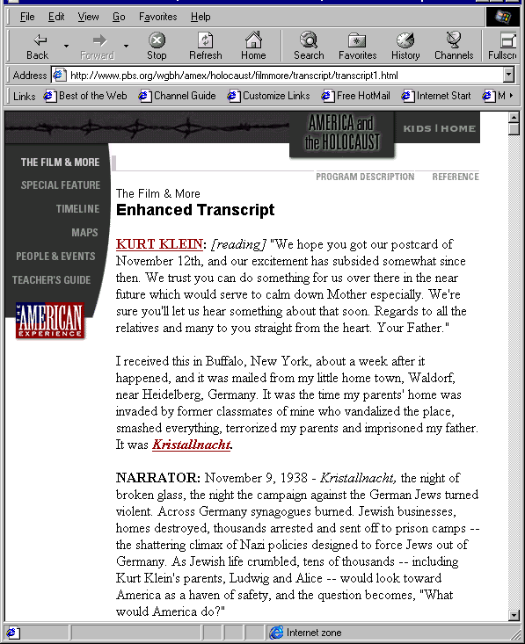
URL
Web Page
Query
Search Engine
Doc Summary+ URL

WWW

Figure 1. Separation of Search and Document Delivery

Thus, we approach the problem of preserving the search context and creating a model of the user’s need by implementing a client or, alternatively, a client-server application linked with the Browser. Such an application can capture the user’s queries and allow the user to elaborate on the information need or paste in relevant information from documents being viewed. Furthermore, it can communicate the representation of the user model to the search service and also apply it to documents as the user is browsing the Web.

As an illustration of this approach we implemented MS Read, an application prototype in the form of an Explorer Bar within MS Internet Explorer (IE).

MS Read captures automatically the user's search queries as communicated by the user through the Browser by analyzing the content and the format of the Web pages. Furthermore, the MS Read user interface enables the user to specify details about the topic of interest in various ways: by typing in more details, cutting and pasting excerpts from the currently viewed document, or including text from other available resources (e.g., lists of names, entities, etc.). In this manner, MS Read captures the expression of the user's information need that the user can communicate at the given time.
The user's input is enhanced using linguistic analyses and semantic expansions. This is achieved using MS Read linguistic module, NLPWin [8], and the linguistic and knowledge resources available to the user, locally or remotely.
For illustration we apply synonym expansion of the original user's input based on the MS Word Thesaurus as well as the abbreviation detection and expansion based on an abbreviation lexicon. The resulting model of the user's interest is then used for document highlighting, as an illustration of the possible document analysis.

MS Read Architecture

The core of MS Read is the mechanism for capturing and processing the user's input to create a context for document analysis. Building on this main functionality we implemented MS Read document highlighting and navigation facility. This core functionality also represents the basis for the future information management facilities of MS Read, including those that provide support in
- Reading and analyzing a single document - by extracting entities and summarizing the text in relation to the selected MS Read context
- Analyzing a set of documents - for example, by re-ranking documents accessed through search and browsing with respect to the MS Read model of the user's information need
- Navigating through Web - by assessing selected links on the currently viewed pages
- Communicating the enriched user model to the search engine to facilitate search refinement (e.g., relevance feedback).
In the following two sections we first give an overview of the MS Read core functionality and then describe the MS Read highlighting and navigation facility.

MS Read Core Functionality
MS Read's core functionality involves three components:
- Module for analyzing document format (e.g., HTML parser)
- Module for the linguistic analysis of text (e.g., linguistic processing of the user's topic descriptions)
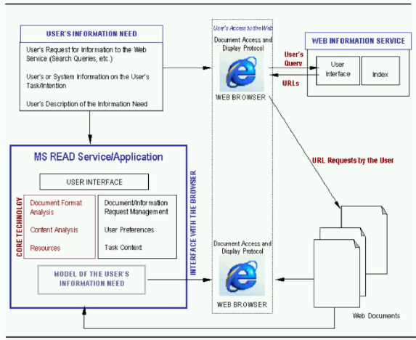
Figure 2. MS Read Architecture
- Linguistic and knowledge resources for enhancing the context.
As the user communicates a request for information via Web browser to a Web information providing service MS Read analyzes the HTML and the events associated with the Web page to identify the user's input and decide whether it is search related. This user input is passed onto the linguistic module that analyzes the text and creates an elaborate linguistic representation of the user's request. Any additional input provided by the user directly to MS Read (via the application GUI) is passed to the linguistic processing module as well.
The linguistic analysis is facilitated by MS NLPWin system ([9]) which produces a rich syntactic and partial semantic analysis of text in the XML format. The later allows for easy experimentation and fine-tuning of the linguistic output to support a particular type of MS Read feature.
In particular, for the purpose of MS Read highlighting facility the linguistic module creates a representation of a query or a topic that includes the following linguistic features:
- Literal formulation of the user's need (e.g., full query or complete text of the topic description)
- Concepts
  - Noun phrases (including multi-word sub-phrases) and single-word terms (e.g., nouns that appear in the topic description without pre-modifiers)
  - Noun phrases with synonym replacements of the head nouns
  - Synonyms of single-word concepts
  - Abbreviation expansions or phrase substitution by abbreviations.
- Keywords
  - Heads of the noun-phrases in the concept category
  - Synonyms of the head nouns
  - Adjectives
  - Verbs.
For example, the linguistic processing of the user's query:
Airfare for a plane journey from Cambridge, UK to New Orleans, LA
yields the following linguistic representation:
1. Full query
Airfare for a plane journey from Cambridge, UK to New Orleans, LA
2. Concepts
airfare for a plane journey
plane journey from Cambridge, UK to New Orleans, LA
airfare
plane
journey
Cambridge (identified as a place entity by NLPWin)
UK (identified as a country name by NLPWin)
New Orleans (identified as a place entity by NLPWin)
LA (identified as a country name by NLPWin)

Furthermore, the singular/plural variances are included as well as the semantic enhancement based on the thesaurus and abbreviation lexicon:

plane journey
expanded using synonym replacement for 'journey' (from MS Read Thesaurus):
trip voyage expedition ride drive flight passage crossing excursion
UK
expanded using the abbreviation lexicon
United Kingdom Great Britain
LA
expanded using the abbreviation lexicon
Louisiana
3. Keywords
plane
journey
with singular/plural variances.
The MS Read highlighting facility uses this representation of the query as the basis for document highlighting.
It is worth noting that the representation of the user's information need can be as comprehensive as desired by the user or required by the user's task. For illustration, let us consider a marketing researcher who is following competitors' products as they are advertised on the Web. One of the knowledge resources that the researcher may want to include into the context creation process by MS Read is a compiled list of competitors with key personnel names or names of the existing products. All these will be highlighted if they occur in the viewed documents on the Web.
The current implementation of MS Read is very efficient due to the fact that the extensive modeling of the query is performed so that effective document analysis can be performed by simple pattern matching of the document text.
Furthermore, depending on the complexity and processing load of the application, MS Read core technology can be used within a client-server architecture. In that case the core technology could be placed on a server.

MS Read User Interface

The GUI of the MS Read prototype application consists of three components that interact with each other and with the MS Internet Explorer (IE) to provide the document analysis and navigation service:
- Topic Manager
- Document Navigator
- Document Highlighter
The components are embedded in the MS Read Internet Explorer Bar (see Figure 3). In other words, the Explorer Bar hosts the user interface and orchestrates the collaboration of the three components. It captures the events associated with the IE, e.g., when IE has finished loading the document, and activates the core technology components, e.g., to perform extraction of features from the page visible within IE (query terms entered in text fields of search pages, document titles, anchor text of the hyperlinks, and similar) and linguistic processing.
Topic Manager
The Topic Manager directly communicates with the MS Read core linguistic technology (see Section 3.1) to obtain the analyses of the user's textual input. It also creates and manages a dynamic list of topics that are either explicitly specified by the user or captured during on-line search, or yet recommended by the MS Read system itself. Indeed, to illustrate the potential of the MS Read approach we implemented a simple feature by which MS Read continuously suggests terminology for highlighting based on the anchor text of the hyperlinks that the user executed and the title of the document that has been accessed as a result.
The topics in the list are candidates for defining the context for highlighting. Each individual topic can be activated and deactivated by the user as desired. Typically search queries are automatically added to the list, assigned a highlighting color, and activated. The MS Read suggested queries, on the other hand, are added to the highlighting context only if the user explicitly activates them. Otherwise they are deleted from the list as a new document is displayed in the browser.
Document Highlighter
Starting with the linguistic analysis of a topic provided by the MS Read core technology, the Document Highlighter assigns a 'significance level' to each category of linguistic features (see Section 3.1). The significance level is a rather informal measure related to the syntactic and semantic characteristics of the features. It suggests the effectiveness of the features in spotting the relevant portions of text and has been introduced primarily to enable a particular highlighting method we decided to implement. Namely, the MS Read Highlighter associates the intensity of the color with the significance level: features with higher significance level are highlighted with the higher color intensity.
Document Highlighter is equipped with the slider bar that enables the user to specify the level of highlighting from Best Hits to All Hits. The pool of highlighted features is increased by adding terminology from more specific to the topic (e.g., the full, literal topic formulation) to less specific ones. For example, keywords get added to the pool after full sentences and multi-word phrases and have the lowest intensity of color.
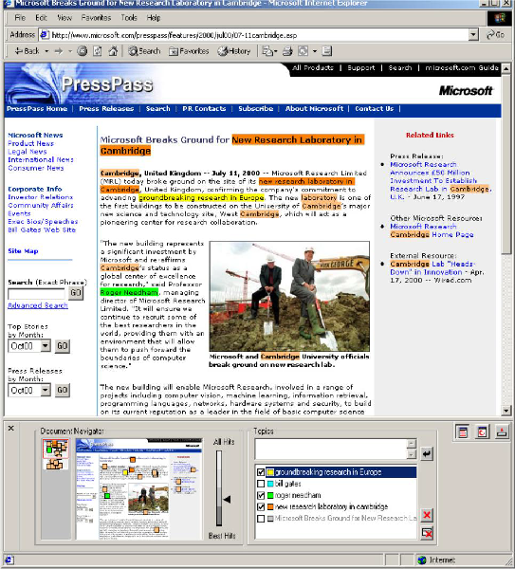
Figure 3. MS Read Explorer Bar in IE 5.5
The highlighting of the document text is facilitated by the IE pattern matching and highlighting facility. The location of the 'hits' within the document is used to perform highlighting in the main IE window but that information is also passed to the Document Navigator.
Document Navigator
The main motivation behind the Document Navigator is to provide the user with an effective way of identifying and navigating to the passages in the document that are potentially relevant to the user's information need. The Document Navigator consists of two thumbnail controls, one of which represents the current view of the main window (detail view), and the other the complete document (overview). As soon as a document is loaded by the IE both thumbnails are computed by rendering the document and scaling it appropriately to fit into the controls. Both thumbnails indicate the positions of 'hits' within the document using small squares. The current implementation enables dynamic presentation of highlights in the thumbnail images as the user changes the levels on the slider bar of the Document Highlighter. On the mouse release, at a desired highlighting level, the highlighting in the IE window is updated.

Evaluation of MS Read
Although the focus of this paper is primarily on the architecture that enables us to capture and apply the user model in the Web environment, we wish to point out a couple of observations from a usability study of an earlier version of MS Read prototype. Full Executive Summary of the usability report is available in the Appendix.
Evaluation was performed on the 11 tasks listed in the Table 1 with 7 participants of various Internet searching experience. A Web search without MS Read served as a baseline against which subsequent tasks were compared.
The significant difference in the user performance of Task 5, in finding the name of a Mexican President, is a clear example of the power of MS Read to support factual research. The task of scanning a long article for relevant information, which other participants had found too difficult to complete, was greatly enhanced by MS Read highlighting.
The other significant difference of interest was an improvement in the ability to correctly assess at a glance whether short articles contained relevant information.
Participants were directed to a list of article abstracts and given 5 seconds to glance at each one and rate it for relevance to the topic of interest. They did one set without MS Read and then a second comparable set with MS Read. The average correlation with

Table 1. Data and statistical comparisons for tasks

Task | Average Performance Score | Average Task  Time | Proportion of 100% successes | Statistical Test
Task 1  Finding the three most common kinds of cancer in About.com or MSN, without MS Read | 0.72 | 276 | 2 of 7 | NA
Task 3  Repeating Task 1 if unsuccessful, or finding the name of an Egyptian religious political party in About.com or MSN, with MS Read | 1.39 | 250 | 3 of 7 | T-test comparing performance scores to scores in Task 1  Not significant, p = .17
Task 4  Using step-by step instructions to find out when Brooklyn became a borough of New York City in Encarta Online | 2.80 | 133 | 7 of 7 | T-test comparing performance scores to scores in Task 1  Significant, p = .01
Task 5  Finding who was the Mexican President during the Mexican War in Encarta Online | 1.66 | 224 | 5 of 7 | T-test comparing performance scores to scores in Task 1  Significant, p = .08  T-test comparing performance scores to previous test of EE ’99 (average = 0.79)  Significant, p = .06
Task 6  Using step-by-step instructions to find out when the pyramids were built in Encarta Online | 2.90 | 160 | 6 of 6 | T-test comparing performance scores to scores in Task 1  Significant, p = .06
Task 7  Finding the name of an Egyptian religious political party or finding the largest volcano in the solar system in About.com or Encarta Online | 0.82 | 283 | 3 of 6 | T-test comparing performance scores to scores in Task 1  Not significant, p = .47
Task 8  Judging relevance of abstracts on curriculum ideas for elementary homeschooling, without MS Read | 0.27  (Average correlation coefficient) | NA | NA | NA
Task 9  Judging relevance of abstracts on the effect of preschool computer use on creativity, with MS Read | 0.59  (Average correlation coefficient) | NA | NA | T-test comparing correlations in Task 8 to Task 9  Significant, p = .07
Task 10  Finding what kind of damage carpenter ants do to houses in MSN or Yahoo | 1.34 | 230 | 3 of 6 | T-test comparing performance scores to scores in Task 1  Not significant, p = .13
Task 11  Search task of participants’ choice | 1.88 | 237 | 3 of 6 | T-test comparing performance scores to scores in Task 1  Not significant, p = .15

objective ratings of relevance improved significantly with MS Read. Participants also gave an average rating of 6.5 (out of 7) for how much they felt MS Read had improved their ability to judge relevance.
The lack of significant differences in Web search tasks may result from a variety of reasons. The problems users experience with generating appropriate queries in Web searches cannot be helped by MS Read—MS Read will simply highlight the misguided query that the user supplied. Thus, while MS Read may help collect the information about the user’s need the effectiveness of that information is coupled with the ability of the Search engine to utilize that information further.
Although participants did not find the Web searches easier with MS Read, they consistently rated it very highly for how much they felt it improved their search. For example, in Task 7 (using MS Read on their own), only half the participants were able to find the information they were looking for, and the average ease of use rating for the task was 2.83 (on a scale from 1 to 7). However, the average rating for how much MS Read improved their chances of finding what they wanted was 6.33 (on a scale from 1 to 7). Clearly participants perceived MS Read as extremely helpful.

Related Work

MS Read is unique among existing Web services and applications with its particular approach to capturing the model of the user need in the Web environment.

Perhaps the most similar work to MS Read is the Reader’s Helper system [7] that focuses on various supports for reading and analysis of electronic documents. The components of the user interface are rather similar. However, while MS Read is primarily concerned with capturing the user context, the work in [7] leaves the acquisition of the description of the user’s need or topic of interest as an open question.

Furthermore, the Google [6] has recently released an extension of the browser, the Google Toolbar that communicates with the Google search service and uses the query terminology typed in the Toolbar to highlight documents. The primary goal of the Google Toolbar is to provide an easy access to the Google search engine and the analysis of accessed documents with respect to the user’s query. As we already pointed out, this is less than ideal in many respects. First, it relies upon the queries to perform document analysis and second restricts the strategies that the user can apply in seeking information. Indeed, it tightly couples local exploration of the documents (searching within a document while reading) with the global search mechanism. While it is conceivable that the Search service could provide within single document search and analysis the same can be done more effectively on the client side, as performed by MS Read.

MS Read is also concerned with the evolving nature of the user model during search and browsing. Recent work by [1] on SearchPad presents an attempt to capture explicitly the user's search context on the client side. SearchPad is implemented as a Web page that lists the user's queries and links of the inspected documents. It uses cookies to store information on the client side and JavaScript embedded in the Search result pages to provide communication with the SearchPad on the user's actions.

MS Read can naturally accomplish the same objective as the SearchPad with the advantage of having information not only about the search queries but a more complete context of the user's information need, captured while user is reading and browsing through documents.

In fact, being independent of any search engine, MS Read could be used as a front-end to any search service: it can transmit to the search engine a more comprehensive representation of the user information need instead of often impoverished user's query. It can also provide the search engines with the valuable information on the user's handling of documents (reading, analyzing, discarding, skimming, etc.)

A meta-search service Copernic [3] provides extensive information about documents in relation to the user's query, including the highlights of the query terms. Copernic compiles search results from a number of search engines, pre-fetches documents from the hosting servers, and analyzes the documents before delivering them to the user. The amount of processing required is considerable and the added value is provided at the expense of speed. Furthermore, in comparison with MS Read, the context applied for highlighting by Copernic is restricted to the search queries.

MS Read provides analysis (highlighting) with respect to a comprehensive model of the user's information need for any viewed document on the Web.

In addition to the Google Toolbar, the FlySwat [5] system also provides an enhancement of the delivered document by including annotations about various types of entities found in the document text, e.g., facts about place entities, persons, etc. For any viewed document the user can request the FlySwat enhancement of the document content. However, that enhancement is not sensitive to the user's current information need. In that respect, MS Read complements FlySwat functionality. It can provide FlySwat with the context of the user's information need in order to present only relevant annotations.

MS Read is an extendible application. It can incorporate various types of information about the user and user's preferences and apply them appropriately in document analysis - the model can be as comprehensive as needed. Furthermore, it can be used to process a set of documents. A straightforward application is a temporary storage and analysis of documents viewed during search and browsing, including the documents linked to the viewed page (thus not seen by the user).

Summary

In this paper we pointed to the implications of the highly distributed and disconnected information management processes in the computing environments like WWW. We show how the apparent lack of context and comprehensive user model could be overcome. We presented a solution to the problem that is based on creating a model of the user's information need on the client side. We claim that this approach is most effective since the model is then readily available as a context for many different information management activities: searching, browsing, reading, document authoring, etc.

We presented a prototype application, MS Read, and discussed the potential for its further development. In particular, we emphasized the fact that the complexity and sophistication of the user model can be varied according to the task it is used for. Even in its early form that includes the Document Highlighter and Navigator, MS Read can be effectively used in conjunction with other Web services and applications. It naturally positions itself as a front-end process that communicates the context of the user's information need to other on-line services and application.

Acknowledgements

MS Read is a result of research work performed by the Integrated Systems team at Microsoft Research, Cambridge, UK. The project greatly benefited from the usability study conducted by Libby Hanna, Usability Expert at Microsoft, Redmond. The software engineering work and user interface design has mosly been done by Robert Tucker, Software Engineer. We acknowledge Robert’s valuable input in our discussions and great implementation work. Many thanks go to all Microsoft researchers who provided feedback on their experience with using MS Read.

References

- Bharat, K. Explicit Capture of Search Context to Support Web Search, In the Proceedings of the 9th International WW Conference, May 2000
- CLARIT Corporation Web Site
http://www.claritech.com; http://www.clairvoyancecorp.com
- COPERNIC Search Service Web Site http://www.copernic.com
- Evans, D. A., Milic-Frayling, N., Lefferts, R.G. CLARIT TREC-4 Experiments. In: The Fourth Text Retrieval Conference (TREC-4). Harman, D.K. (Ed.). NIST, 1996
- FlySwat Service Web Site
http://www.flyswat.com
- Google Search Site
http://www.google.com
- Graham, J., The Reader’s Helper: A Personalized Document Reading Environment, CHI’99, 1999
- Jensen, K., Heidorn, G.E., and Richardson, S.D. eds. Natural Language Processing: The PLNLP Approach. Kluwer Academic Publishers, 1993.
- Rijsbergen, C.J. van. Information Retrieval. Butterworths, London 1975, 1979
- ThirdVoice Web Site
http://www.third.voice
- Web Site on the ThirdVoice Dispute
http://saynotothirdvoice.com

Appendix

User's Reaction to the Early Prototype - MS Read v.1.0

The first implementation of MS Read, v.1.0, was a subject of the usability test to assess its effectiveness in supporting users in search and relevance assessment tasks, and to gauge the appeal and interest users might have in this kind of feature. Its basic functionality was the analysis of keywords and concepts in users’ search queries and in users’ further descriptions of the topic of interest. This model of the user's interest was used for highlighting of text in online documents with the primary goal to help users assess document relevance and spot details in the text.

Executive Summary and User's Rating

From MS Read Formative Usability Test, IDIS #6581
Report by Libby Hanna
Microsoft Research, Redmond
June 16, 2000

The participants were 7 adults between the ages of 36 and 61, three women and four men. They were classified according to Internet Screening Interviews as 2 Beginning Internet Users and 5 Intermediate Internet Users.
Participants consistently rated MS Read very highly on satisfaction and how much they felt it improved their ability to find information. However, they did not rate tasks using MS Read on their own as any easier to complete than tasks without MS Read.
- In ease of use and satisfaction ratings, participants rated only one task significantly easier to do with MS Read than without MS Read: following step-by-step directions to use MS Read to find a fact in an online encyclopedia article. Although they found the other tasks using MS Read difficult to perform, they continually rated MS Read positively for how much they felt it improved their ability to do the task. For example, the average rating for the ease of completing Task 7 was 3.82 (on a scale from 1 to 7, where 1 is very negative and 7 is very positive). Task 7 involved either finding the name of an Egyptian religious political party or finding the largest volcano in the solar system (depending on what tasks participants had previously completed), and only half the participants were able to complete this task

successfully. However, the average rating for how much participants felt MS Read improved their ability to find what they were looking for in the same task was 6.29.
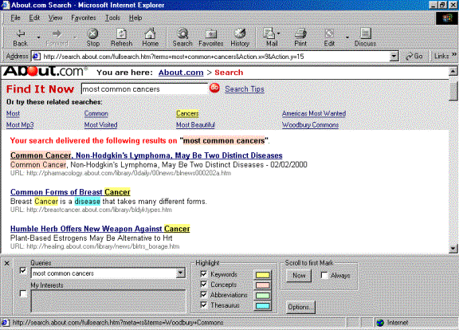
Figure A1: Screen shot of MS Read showing highlighting for the query “most common cancers” in the search engine on About.com.
Participants had a significantly more positive perception of MS Read after finishing the test than when they first looked at it, even though it had not made the tasks easier or more successful.
- One other statistically significant finding in comparisons of satisfactions ratings was that participants rated their satisfaction with MS Read at the end of the test higher than their initial impression of MS Read – with an average of 6.43 at the end compared to 5.43 at first look.
Although participants were not much faster or more successful at tasks using MS Read than they had been without, there was one task where they showed significantly more success than participants in previous usability tests.
- In performance data participants were significantly faster and more successful at completing tasks with MS Read versus without MS Read in general only when they were following step-by-step instructions. When left to their own inclinations on how to use MS Read, they were not able to improve their performance. However, their performance was much more successful in one task that can be compared to a previous usability study of another product. A task that has been notoriously difficult for participants in other usability studies is finding out who was the Mexican President during the Mexican War in Encarta Encyclopedia. Four of the six participants in this test who tried this task on their own were able to succeed using MS Read.
Some participants were more successful at accurately judging relevance of documents with MS Read than without, while others were not. However, all participants felt it made the task of judging relevance much easier.
- In quickly judging the relevance of document abstracts using MS Read versus without MS Read, participants’ data varied based on their reading speed. Participants’ ratings were correlated with an “objective” set of ratings (based on a full reading of the abstract and count of keywords and concepts). Only half the participants showed a positive correlation when not using MS Read, but all the participants correlated positively when using MS Read. Those participants who correlated positively when not using MS Read showed no improvement in correlations when using MS Read, but those who were negatively correlated when not using MS Read showed a dramatic improvement with MS Read. All participants rated MS Read very highly for how much they felt it improved their ability to judge relevance, with an average rating of 6.5.

Revisions for more sophisticated linguistic analyses appeared to make MS Read somewhat less supportive and comprehensible to users than before. However, this may be because the tasks for the test were designed for the previous version.

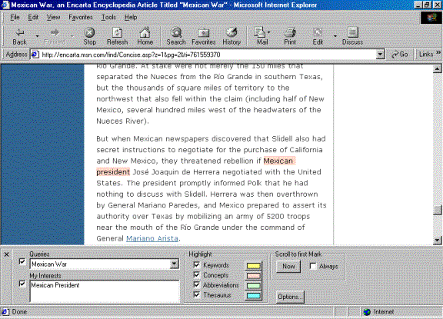

Figure A2: Original query is Mexican War. The user is interested in the name of the Mexican President.
- The last two participants used a revised version of MS Read that included a more sophisticated linguistic analysis in highlighting. There is not enough data to compare their performance statistically with that of the other participants and their numbers appear similar to the others.
- However, the kind of highlighting they saw was substantially different than the other participants. For example, in the first version of MS Read during the document relevance task, the word “creativity” appeared in yellow as a phrase fragment, clearly differentiated from the keywords all highlighted in beige. Using the revised MS Read, “creativity” appeared in beige with all the other keywords.

In conclusion, MS Read was highly attractive and appealing to participants, but needs some improvements in how easily users can learn and combine features effectively to truly support their work.

Performance scores are a measure of the efficiency of performing tasks that takes into account both the amount of time and the amount of success. The score is computed as 1/task time x success rate x time limit (300 seconds). Higher scores reflect faster/shorter times and greater success.
Participants were given 5 minutes (300 seconds) to perform tasks.
Success rates are defined as follows: 100% means participant found correct information on page; 75% means participant had correct information visible in page but did not identify it; 50% means participant was in Web site that contained correct information but it was not visible; 25% means participant had results list with Web site listed that contained correct information.
Statistical tests in usability research are used liberally to look for all possible trends with small sample sizes. Here comparisons were done using within-subject t-tests to use as much power as possible to spot significant differences. All findings with a chance probability of less than 10% (p < .10) are considered statistically significant.

