The Learning Experience Project:
Enabling Collaborative Learning with ConferenceXP

Jay Beavers; Tim Chou; Randy Hinrichs; Chris Moffatt;
Michel Pahud; Lynn Powers; Jason Van Eaton

April 2004

Technical Report
MSR-TR-2004-42

Microsoft Research
Microsoft Corporation
One Microsoft Way
Redmond, WA 98052

The Learning Experience Project:
Enabling Collaborative Learning with ConferenceXP
Jay Beavers, Tim Chou, Randy Hinrichs, Chris Moffatt,
Michel Pahud, Lynn Powers, Jason Van Eaton
One Microsoft Way, Redmond WA 98052 USA
+1 425 882 8080
{jbeavers; timchou; randyh; chrismof; mpahud; jasonv} @microsoft.com

Abstract
The Learning Experience Project is an initiative of Microsoft Research’s Learning Sciences and Technology group. The goal of this project is to explore how to make collaborative learning a compelling and rich experience by assuming the availability of emerging and enabling technologies, such as high-bandwidth networks, wireless devices, Tablet PCs, and the advanced features in Microsoft® Windows® XP. The foundation of the Learning Experience Project is the ConferenceXP research platform. ConferenceXP enables universities to build less infrastructure and concentrate on researching and developing collaborative applications that enhance the learning experience in and out of the classroom. By delivering high-quality, low-latency audio and video over broadband connections, as well as providing a flexible common framework, ConferenceXP supports the development of real-time collaboration and videoconferencing applications.

Keywords
videoconferencing, collaboration, conferencing, distributed applications, distance learning, conferencing, Tablet PC, multicast, wireless

Introduction
When we look at the classrooms of today, we can see that technology has enhanced learning in a number of ways. For example, personal computers enable students to view three-dimensional molecular models, instantaneously hear the music they’re composing, and see the effects of many variables in simulated visual ecosystems. But as we look toward the future, we see technology not only enhancing learning, but also transforming how we learn.
At Microsoft Research, the Learning Sciences and Technology group has a vision for learning in the twenty-first century: to transform the learning experience by creating technology that supports how we learn. The Learning Experience Project is one of the initiatives we are working on in pursuit of this vision. Our objective is to collaborate with leading researchers in the field of learning sciences to research technology-enhanced learning solutions and to enable the development of rich, immersive, and collaborative applications that enhance the learning experience.
In this paper, we describe the activities of the Learning Experience Project. We also describe the ConferenceXP research platform, which provides the foundational infrastructure for the Learning Experience Project and enables the creation of next-generation, pedagogically sound learning applications.

Enhancing Learning with Technology
Over that last two decades, we’ve seen computational power, graphics power, and storage capacity increase every year. These technological advances have had an enormous impact on business applications. Today, we’re seeing the emergence of devices and technology that support collaborative and mobile learning in ways we have envisioned for many decades. For instance, Tablet PCs enable students to collaborate with ink in interactive workspaces, both synchronously and asynchronously. With wireless and high-bandwidth networks, enhanced with high-quality, low-latency audio and video, students can more interactively attend classes from a distance. Additionally, these networks enable easy access to content, collaborators, experts, mentors, and laboratories, so students can truly work from anywhere. Such mobility allows students to learn in real-world contexts, outside of the lecture hall and in the field, where learning takes place more naturally.
Along with these technological advances, we can learn from past and present research and development projects focused on enhancing the learning experience. For example, the Future Computing Environments (FCE) group at Georgia Institute of Technology created eClass, formerly known as Classroom 2000, which focused on enhancing learning by using electronic blackboards and notebooks.
Researchers have also been working on advancing audio and video technology. For example, Milton Chen at Stanford created Video Auditorium, a videoconferencing system that enables distance learning with telephone-quality audio and television-quality video. At Microsoft Research, the Collaborative and Multimedia Systems group created Flatland, a desktop-to-desktop presentation support system that provided feedback channels to a remote presenter. They also created TELEP, a tele-presentation environment for live and remote desktop audiences. This system enhanced the local and remote viewers’ experience of multicast presentations.
Currently, the Massachusetts Institute of Technology (MIT) is partnering with Microsoft Research on the iCampus project, which is transforming how teachers teach and students learn. For instance, the Technology Enabled Active Learning (TEAL) project engages students in introductory physics classes by incorporating animations, simulations, and hands-on exercises in the course materials.
These technological advances and research projects show that the potential for transforming how we learn is limited only by our imagination. Inspired by a vision for learning in the twenty-first century, Microsoft Research’s Learning Sciences and Technology group builds on previous and ongoing research in the field to explore how technology can help transform the way we learn.

The Learning Experience Project
From recent research in the learning sciences, we know collaboration, presence awareness, and engagement in learning are important. To expand research in these areas, the Learning Sciences and Technology group started the Learning Experience Project. This research initiative is focused on using emerging technology to enable collaborative, engaging, and highly interactive learning experiences.
The foundation of the Learning Experience Project is the ConferenceXP research platform. This platform enables the development of highly collaborative applications by offering high-quality, low-latency audio and video. It also serves as an open research platform by providing a flexible, common framework for designing and implementing collaborative learning applications.
By partnering with research organizations and universities — such as the University of Washington, Brown University, University of California at Berkeley, and Carnegie Mellon University — the Learning Experience Project combines the academic community’s expertise in the learning sciences with Microsoft’s expertise in technology. It enables researchers and developers to create distributed applications for learning that take advantage of not only ConferenceXP technology, but also Tablet PCs and wireless networks. It also enables them to develop the collaborative tools and applications they need without having to build them from the ground up. From this partnership, several research papers on topics related to the Learning Experience Project have been published.
As a research initiative, the Learning Experience Project conducts deployment trials around the country. The Learning Experience Project team evaluates the effectiveness of ConferenceXP technologies used for teaching and learning in these trials to improve the ConferenceXP platform and the learning applications it supports.
In addition, the Learning Sciences and Technology team hosts a Community Web site, which provides information about the Learning Experience Project and supports researchers, developers, and implementers in the academic community. This site also offers ConferenceXP application and source code downloads, documentation, and related research papers. And it enables developers and implementers to provide feedback about ConferenceXP to the Learning Experience Project team and offers a community message board, where participants can discuss and share ConferenceXP experiences and solutions. Our goal for the Web site is for it to grow into a self-sustaining community of developers, researchers, and implementers.
In the following sections, we’ll take a closer look at the ConferenceXP research platform and how it provides an extensible foundation for collaborative environments.

The ConferenceXP Research Platform
When we started the Learning Experience Project, we surveyed the academic community to understand their needs and requirements for technology-enhanced learning. We then identified important needs and requirements that could be tackled through the design and development of innovative technology solutions. We chose to focus on the widely expressed need for an infrastructure to support high-end conferencing and collaboration for use in both traditional and distance learning environments. In supporting the development of learning environments and applications, we wanted the infrastructure to be inexpensive and easy to deploy.
From these assessments, we outlined the following design goals for the ConferenceXP research platform:
- Rich experience — Integrate high-performance audio, video, and network technologies into a rich, immersive environment for instruction, conferencing, and collaboration.
- Ease of use — Enable participants to join online conferences, presentations, and meetings by using a simple point-and-click user interface. Ensure easy hardware and software setup by supporting standard plug-and-play devices and installing (and uninstalling) as a standard Microsoft® Windows® application.
- Scalability — Support a simple single-computer-per-node architecture, without requiring a complex server-based infrastructure, that can share high-quality audio and video between multiple local and remote locations. Support multicast to accommodate large classrooms with high throughput.
- Extensibility — Provide APIs that enable the development of custom user interfaces and applications.
- Advanced technologies — Build 100% managed code on the Microsoft .NET Framework. Support wireless networks and Tablet PCs. Integrate advanced media and display technologies, such as Microsoft DirectShow®, Microsoft Windows Media®, and Microsoft DirectX®.
With these design goals in mind, we designed the architecture of the ConferenceXP platform.

ConferenceXP Architecture
ConferenceXP enables developers to build a set of interoperable solutions on top of a common framework. With published APIs and a set of base classes, developers and researchers can design powerful new conferencing and collaborative environments, create custom interfaces, and integrate ConferenceXP with existing conferencing and classroom systems. The difficult parts of developing collaborative applications — forming groups, managing group state and status, dealing with network errors — are taken care of by the ConferenceXP platform and its services.
ConferenceXP employs a peer-to-peer architecture. Because no server is involved, this architecture makes deployment easy, and it prevents network traffic bottlenecks and single points of failure. This architecture uses multicast to ensure efficiency and scaling for multipoint video conferencing over a broadband network, as well as for sharing documents and ink over a 802.11b wireless network. It also supports point-to-point unicast for environments where multicast is unavailable.
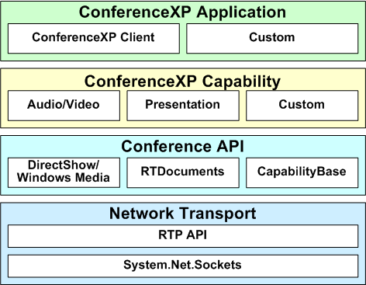
Figure 1 The architecture of the ConferenceXP research platform
The ConferenceXP architecture enables developers to create ConferenceXP learning applications that take advantage of the underlying network, conferencing, and distributed application protocols. It is divided into four logical layers: ConferenceXP Application, ConferenceXP Capability, Conference API, and Network Transport.

ConferenceXP Application and Capability Layers
The ConferenceXP Application and Capability layers provide the user interface for ConferenceXP. Capabilities are add-in components that add functionality to a ConferenceXP application. Both ConferenceXP applications and capabilities use the Conference API.
The user interface of the ConferenceXP Client application is designed so that it can be easily customized. Developers who build on the ConferenceXP platform can use the built-in ConferenceXP Client application, customize or extend the built-in applications, or use the audio and video conferencing features in their own custom-built learning application.
The ConferenceXP Capability layer includes the Audio/Video and Presentation capabilities included with ConferenceXP. The Audio/Video capability enables a ConferenceXP application to send and receive audio and video streams, and the Presentation capability enables a ConferenceXP application to send and receive documents and ink.
Developers can create multipoint collaborative capabilities for the built-in ConferenceXP Client application or for their own ConferenceXP application, either by writing them from scratch or by modifying existing Windows applications built on the .NET Framework.

Conference API Layer
By using the Conference API, developers can quickly and easily create a ConferenceXP application or capability. For example, capabilities can inherit from the CapabilityBase class, which performs most of the work and enables developers to convert most applications into a capability in under 100 lines of code.
The RTDocuments API provides applications and capabilities with a standard protocol to transfer documents and ink strokes. By using the RTDocuments protocol, applications and capabilities that handle documents and ink can interoperate with each other. The RTDocuments protocol is a Microsoft .NET runtime implementation of the IMS/
SCORM interchange specification.
The DirectShow and Windows Media APIs provide access to audio and video features in Windows. The DirectShow API provides a .NET wrapper around the DirectShow multimedia API so that ConferenceXP applications and capabilities can use them to connect devices with codecs, as well as send audio and video data over the network. ConferenceXP applications and capabilities can also use Windows Media audio and video codecs.

Network Transport Layer
The Network Transport layer provides custom-written network transport technology to ensures audio, video, and data streams are transmitted with minimum data loss. ConferenceXP sends audio, video, and data streams over the network by using an implementation of the Real-time Transport Protocol (RTP), which is based on the managed implementation of Windows Sockets (System.Net.Sockets).
The RTP peer-to-peer network transport is an Internet Engineering Task Force (IETF) standard for audio and video transmission. It is designed for scenarios where low latency is required, such as high-performance conferencing. To help prevent data loss in difficult network environments, such as wireless networks in large classrooms, ConferenceXP uses extensions to the RTP protocol, as well as forward error correction (FEC) algorithms.

ConferenceXP Built-in Applications
Developers who build on the ConferenceXP platform can take advantage of ConferenceXP conferencing and collaboration technology. ConferenceXP includes two user interfaces: ConferenceXP Client and ConferenceXP for Windows Messenger.

ConferenceXP Client
The ConferenceXP Client application enables you to interact and collaborate with others in a virtual collaborative space, called a venue. When you start ConferenceXP Client, it opens a window that displays the available venues you can join.
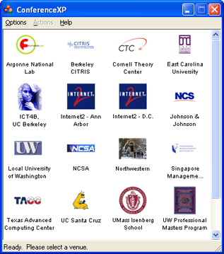
Figure 2 The ConferenceXP window displays venues you can join.
After you join a venue, ConferenceXP automatically starts the multipoint real-time audio and video capability, which enables you to see and hear others in the same venue. You can choose whether you want to automatically send and receive audio and video streams, and you can specify how the video windows display onscreen.
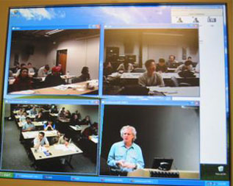
Figure 3 Tiled video windows showing a four-way conference.
The ConferenceXP Client application includes two sample capabilities: ConferenceXP Presentation and Chat. With ConferenceXP Presentation, participants can collaborate with real-time ink on an electronic whiteboard or distributed Microsoft PowerPoint® presentation. Chat enables participants to send instant messages to each other.
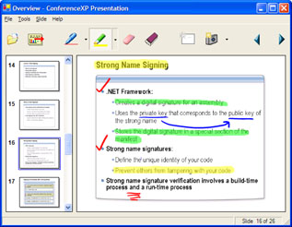
Figure 4 ConferenceXP Presentation enables real-time inking and collaboration on a whiteboard or PowerPoint presentation.
ConferenceXP audio and video support is designed for high-speed networks — 2 megabits per second (Mbps) or faster — which enables high-quality multipoint conferencing. It delivers full-screen video at 30 frames per second and supports three video data transfer rates:
- High — 1.5 Mbps compression at 640 x 480 resolution
- Medium — 512 kilobits per second (Kbps) compression at 320 x 240 resolution
- Low — 256 Kbps compression at 320 x 240 resolution
As a peer-to-peer application, ConferenceXP sends audio, video, and data streams between ConferenceXP clients, instead of sending these streams to or receiving them from a server. To support simultaneous users while keeping network traffic to a minimum, ConferenceXP uses multicast. This way, a ConferenceXP client can send a stream once to all ConferenceXP clients set up to receive the data.

ConferenceXP for Windows Messenger
With ConferenceXP for Windows Messenger, you can have video and voice conversations with your Microsoft Windows Messenger or MSN® Messenger contacts. ConferenceXP for Windows Messenger transmits high-quality audio and video streams over unicast. It takes advantage of high-performance video codecs to deliver enhanced two-way conferencing in Windows Messenger or MSN Messenger.
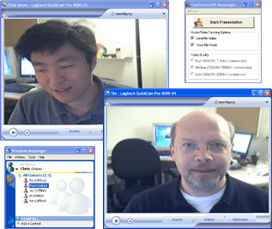
Figure 5 ConferenceXP for Windows Messenger enables two-way video conferencing over unicast.
Like the ConferenceXP Client application, ConferenceXP for Windows Messenger includes the ConferenceXP Presentation capability for real-time inking and collaborating on a shared whiteboard or distributed PowerPoint presentation.

Developing Learning Applications
When we look at traditional classrooms today, we see teacher-centric lectures. The teacher typically presents a lecture at the front of class, using an overhead projector or a PowerPoint presentation to display an outline, solve problems, or provide examples, and the students take notes and ask questions.
By enhancing the traditional method of teaching, ConferenceXP technology enriches the learning experience. For example, in a classroom equipped with a wireless network, students can view the professor’s PowerPoint presentation and add their own notes with ink on their Tablet PC. They can also use a collaborative learning application to work on projects and solve problems with other students.
Universities can design prototype collaborative and immersive applications that take advantage of the ConferenceXP platform and enhance the teacher, student, and mentor experience. For example, the following applications have been developed by partner universities.

Classroom Presenter
The University of Washington created Classroom Presenter, an advanced presentation system for distance learning, education, and lecture environments. As a research application, Classroom Presenter has been the subject of many published research papers.
With Classroom Presenter, professors can project their Microsoft PowerPoint presentation to a projector screen as well as to student notebooks and Tablet PCs. Professors can then add real-time ink on their Tablet PC to highlight text, draw an illustration, or solve an example problem. Students can receive the professor’s presentation in real time on their devices and add their own notes during the lecture. The students can see the professor’s notes, but the professor cannot see the students’ notes. Classroom Presenter also includes enhanced features for interactive feedback, such as enabling students to send a “slower,” “just right,” or “faster” message about the pace of the class to the professor.
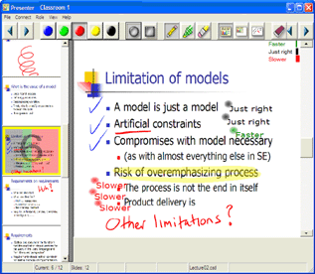
Figure 6 Professors can add real-time ink to their projected lecture notes with Classroom Presenter.
Classroom Presenter uses the RTDocuments protocol to send and receive presentation slides and ink. By using this protocol, Classroom Presenter can interoperate with other programs that support the RTDocuments protocol, such as ReMarkable Texts and ConferenceXP Presentation.

ReMarkable Texts
Developed by Brown University, ReMarkable Texts provides a compelling student experience. With ReMarkable Texts, students can view and organize their classroom notes, presentations, and other documents. Students can annotate their classroom notes with ink, hyperlinks, sticky notes, and audio, and then can later search their notes by annotation type.
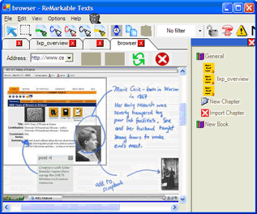
Figure 7 Students can annotate and organize their class notes in ReMarkable Texts.
Like Classroom Presenter, ReMarkable Texts supports the RTDocuments protocol, which enables it to share documents and ink with other applications that also support the RTDocuments protocol. For example, an instructor can use Classroom Presenter for the lecture slides, while students can use ReMarkable Texts to receive the slides and add notes. Then when the class is over, students can organize the presentation with their other class notes in ReMarkable Texts.

Magic Paper
The Massachusetts Institute of Technology (MIT) developed Magic Paper, a physics sketchpad. With Magic Paper, students can draw objects and then animate those objects to see the laws of Newtonian physics in action. Students and teachers can use a collaborative version of Magic Paper in small-group learning environments, where students can interact with each other around a physics sketch in real time — in the same classroom, across campus, or across the world.
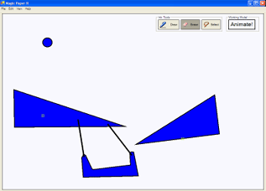
Figure 8 Students can draw objects and then animate those objects in Magic Paper.
By using the Conference API, the Learning Sciences and Technology group easily converted the stand-alone version of Magic Paper to create the collaborative version, which required less than 100 lines of additional code.

Interactive Virtual Lab
The University of Massachusetts at Amherst used ConferenceXP to develop Interactive Virtual Lab. With this virtual laboratory application, students dispersed in different geographical areas can work together in virtual laboratory groups and learn how to use the physical laboratory equipment. Because Interactive Virtual Lab integrates ConferenceXP technology, students and instructors can seamlessly access the physical lab while they interact, collaborate, and solve problems with each other in real time.
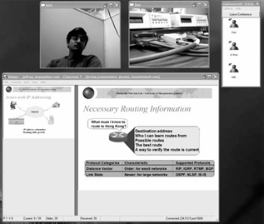
Figure 9 Students dispersed in different geographical areas can use Interactive Virtual Lab to work together in the same lab.

InkBoard
Also developed at MIT, InkBoard is a collaborative sketching application designed for the Tablet PC. It enables design teams to interact with each other by using real-time ink strokes. It uses the Conference API to support video and audio conferencing.
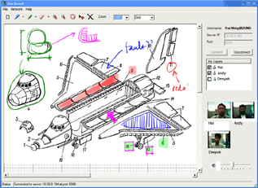
Figure 10 InkBoard enables design teams to collaborate on a project.

Collaborative Weather Information System
The Collaborative Weather Information System was developed as a student project at the University of Massachusetts Amherst. This system enables researchers to share weather data and collaborate with other researchers at other universities in real time.
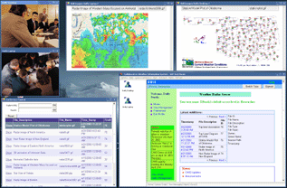
Figure 11 Researchers can share weather data and collaborate with other researchers in real time with the Collaborative Weather Information System.
The Collaborative Weather Information System is built on the ConferenceXP platform to enable audio and video conferencing, and the user interface is a customized version of the ConferenceXP Client application.

Deploying ConferenceXP
To assess the effectiveness and outcomes of technology, the Learning Experience Project conducts classroom and distance trials in teaching and learning scenarios. ConferenceXP is currently being deployed for distance learning at a number of universities, including the University of Washington, Brown University, Carnegie Mellon University, University of Texas at Austin, University of California at Berkeley, and Cornell University.
The University of Washington uses ConferenceXP for their Professional Master’s Degree Program. This established distance-learning course was ideal for assessing ConferenceXP in the classroom. Before using ConferenceXP, this course used ISDN-based video conferencing, Microsoft NetMeeting® for PowerPoint presentation distribution, an electronic whiteboard, and a lecture archive. ConferenceXP offered higher quality audio and video, as well as easy setup. Classroom Presenter on a Tablet PC provided interactivity with ink on PowerPoint presentations.
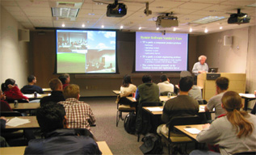
Figure 12 The University of Washington uses ConferenceXP to deliver the Professional Master’s Degree Program.
The lessons learned from the first deployment resulted in several improvements, such as reduced transmission failures, decreased background room noise, better lighting and camera management, and optimized overhead projector positions. From additional deployments and assessments, we learned that the ConferenceXP experience greatly benefits from rooms dedicated to distance learning, as well as diagnostic and configuration capabilities to correct audio, video, and network problems quickly.
To enable asynchronous playback of lectures from a Web page, the University of Washington currently provides an archival solution for ConferenceXP called Windows Media Gateway. This solution enables a student with a computer and broadband connection to later watch a lecture they missed with Microsoft Internet Explorer and Windows Media Player.
With the Professional Master’s Program deployment, the Learning Sciences and Technology group and the developers of Classroom Presenter were able to study the teacher and student experience of the Tablet PC–based lecture presentation system and distance-learning videoconferencing, producing several relevant research papers.

Looking Forward
By encouraging students to learn by doing, ConferenceXP technology is a step towards transforming how students learn in the twenty-first century. Our collaboration with the research community continues to deliver prototype learning applications that take advantage of technology. The Learning Experience Project is dedicated to enhancing the learning experience with extensible, customizable technology that supports learning in and out of the classroom. We’re looking forward to enhancing ConferenceXP, including adding support for simulation and visualization applications, virtual environments, and games.

Further Reading
A Vision for Life Long Learning — Year 2020
http://www.conferencexp.net/community/library
/VisionforEducation.doc
Visions 2020: Transforming Education and Training Through Advanced Technologies
http://www.conferencexp.net/community/library
/2020Visions.pdf
Technology, Learning and Scholarship in the Early 21st Century
http://www.conferencexp.net/community/library
/LearningXP.doc
Learning Science and Technology R&D Roadmap
http://www.thelearningfederation.org/execsum.pdf
Bransford, John D., Ann L. Brown, and Rodney R. Cocking, eds. How People Learn: Brain, Mind, Experience, and School (Expanded Edition). Washington: National Academy Press, 2000.
National Research Council, J.W. Pellegrino, N. Chudowsky, and R. Glaser, Eds. Knowing What Students Know: The Science and Design of Educational Assessment. Washington: National Academy Press, 2001.

On the network, a venue is a multicast endpoint defined by an IP address and port.
http://www.cc.gatech.edu/fce/eclass/
http://graphics.stanford.edu/papers/virtual_auditorium/
http://research.microsoft.com/scg/vworlds/vworlds.htm
http://research.microsoft.com/coet/telep_page.aspx
http://icampus.csail.mit.edu/index.shtml
Bransford, John D., Ann L. Brown, and Rodney R. Cocking, eds. How People Learn: Brain, Mind, Experience, and School (Expanded Edition). Washington: National Academy Press, 2000.
http://www.conferencexp.net/community /Default.aspx?tabindex=4&tabid=70
http://www.learningexperienceproject.net or http://www.conferencexp.net
ConferenceXP RTDocuments Specification http://www.conferencexp.net/community/library /RTDocsSpecification.htm RTDocuments Talk, given by Jay Beavers http://www.conferencexp.net/community/library/producer /RTDocumentsTalk/RTDocumentsTalk_files/Default.htm
For more information on IMS standards and how they were developed, visit http://www.imsproject.org. For more information about the Advance Distributed Learning (ADL) initiative and Sharable Content Object Reference Model (SCORM), visit www.adlnet.org.
Real-time Transport Protocol (RTP) Specification http://www.conferencexp.net/community/library /RTPSpecification.htm
http://www.cs.washington.edu/education/dl/presenter/
http://www.cs.washington.edu/education/dl/presenter /papers.html
http://www.cs.brown.edu/research/graphics/research /ReMarkableTexts/
A New Model for Remote Laboratory Education Based on Next Generation Interactive Technologies http://www.conferencexp.net/community/library/papers /aseeivlab.pdf
http://www.people.umass.edu/oo/cwis/
http://www.cs.washington.edu/masters/
http://www.cs.washington.edu/education/dl/confxp /wmgateway.html
Experiences with a Tablet PC-Based Lecture Presentation System http://www.conferencexp.net/community/library/SIGCSE.pdf Videoconferencing and Presentation Support for Synchronous Distance Learning http://researchers.conferencexp.net/Lists/Research Papers2 /Attachments/3/FIE 2003.doc

